**Scientific Methodologies for Advanced Research and Teaching through the Alliance of Alliances - SMART-A2**

**List of participants**

| **Participant No.** | **Participant organisation name** | **Country** |
| --- | --- | --- |
| **1**  **(Coordinator)** | NOVA UNIVERSITY OF LISBON-**NOVA** | PORTUGAL |
| **2** | ALMA MATER STUDIORUM - UNIVERSITY OF BOLOGNA-**UNIBO** | ITALY |
| **3** | STAB VIDA INVESTIGAÇÃO E SERVICOS EM  CIENCIAS BIOLOGICAS LDA-**STABV** | PORTUGAL |
| **4** | NATIONAL AND KAPODISTRIAN UNIVERSITY OF ATHENS-**UOA** | GREECE |
| **5** | EXELIXIS RESEARCH MANAGEMENT AND COMMUNICATION-**EXEL** | GREECE |
| **6** | UNIVERSITY OF CAMPINAS-**UNICAMP** | BRASIL |
| **7** | YAGHMA-**YAGHMA** | THE NETHERLANDS |
| **8** | UNIVERSITY OF PERNAMBUCO-**UPE** | BRASIL |
| **9** | TARAS SHEVCHENKO NATIONAL UNIVERSITY OF KYIV-**TSNUK** | UKRAINE |
| **10** | UNIVERSITY OF HUELVA-**UHU** | SPAIN |

**1. Excellence** #@REL-EVA-RE@#

**1.1. Objectives** #@PRJ-OBJ-PO@#

By 2030, our **SMART-A2** consortium—bringing together leading institutions from major European University Alliances—aims to transform science education across Europe and Brazil by shifting from passive, theory-heavy teaching to practical, personalised, digitally enhanced learning (Fig. 1 and <https://smartupdreducation.wixsite.com/welcome/project-video>). The centre of gravity of SMART-A**2** lies in Widening countries, with the majority of leadership roles, activities and institutional reforms driven by partners in Portugal, Greece and Ukraine (<https://smartupdreducation.wixsite.com/welcome/project-slides>). At the centre of this transformation is the 1 Student – 1 Apparatus (1S1A) model, enabled by the Dr. Vida Education Education device: a compact, eco-friendly, multitask, LED-based instrument costing under €1000 per unit. Dr. Vida Education functions as a modern “Swiss-army-knife” laboratory, capable of performing key analytical procedures such as fluorescence measurements, PCR-based DNA amplification, UV-VIS measurements and real-time data acquisition (see preliminary data: (<https://www.jiomics.com/index.php/jiomics/article/view/250/305>). Its embedded artificial intelligence provides instant feedback, supports bioinformatics analysis, and guides students through adaptive learning pathways tailored to their performance. (preliminary site: [***https://smartupdreducation.wixsite.com/welcome***](https://smartupdreducation.wixsite.com/welcome) ***password: SMART:*** 5min explainer). This approach directly addresses a longstanding challenge: in many educational systems, students learn science as spectators rather than practitioners. By contrast, **SMART-A2** places a functional laboratory directly into each teacher’s and student’s hands, replacing passive observation with active experimentation. The device’s portability and battery operation enable learning anywhere—classrooms, fieldwork sites, or even at home—democratising access to scientific practice and reducing the logistical pressure on institutional laboratory facilities. The result is a measurable increase in student engagement, competence, and autonomy. The pedagogical impact extends beyond individual learning. Dr. Vida fosters interdisciplinary teamwork, allowing educators and students in environmental sciences, chemistry, biomedicine, engineering, and bioinformatics to collaborate on real-world challenges such as monitoring water contaminants (e.g., mercury or arsenic), mapping pathogen prevalence (e.g., *Salmonella* or *Legionella*), or modelling environmental and health risks (e.g.: lactose intolerance). By breaking down disciplinary silos, teachers and students learn not only technical skills but also how their expertise integrates into broader societal contexts. The project’s scalability is rooted in what we define as an “Alliance of Alliances”, leveraging five major European University Alliances that together represent 49 universities and four associated partners across 23 countries. These structures—EUTOPIA, EPICUR, CIVIS, UNA EUROPA, and SEA-EU (Table A)—provide long-established governance, mobility schemes, and communication networks that will be activated to deploy and expand the 1S1A model. Brazilian universities join this framework, ensuring global reach and South–North cooperation. Cross-alliance mobility and training will support teachers, laboratory technicians, and administrative and IT staff in mastering AI-enabled practical teaching, interdisciplinary module creation, safety protocols, and device maintenance. These activities will be coordinated through existing alliance mechanisms such as **EUTOPIA’s Connected Learning Communities, EPICUR’s Inter-University Campus, CIVIS’ Thematic Hubs, UNA EUROPA’s collaborative formats, and SEA-EU’s joint programmesì**. Ultimately, the project aims to catalyse a broad educational, scientific, and societal impact. By enabling every student to become an active experimenter, we expect a significant increase in engagement and scientific literacy, with projections of more than 10,000 learners benefitting annually by 2030. In addition to transforming science education, SMART-A2 implements a coordinated programme of *institutional R&I modernisation* fully aligned with the European Research Area (ERA) Policy Agenda 2022–24 and the Agreement on Reforming Research Assessment (CoARA). Partner HEIs will adopt pilot measures for modern research assessment, strengthen their Research Management and Administration (RMA) units, streamline open-science workflows, and introduce new data-governance and digital-R&I processes that support researchers, technicians, and R&I support staff. These institutional reforms ensure that SMART-A2 contributes directly to the ERA priority of empowering higher-education institutions as drivers of excellence in the European R&I system.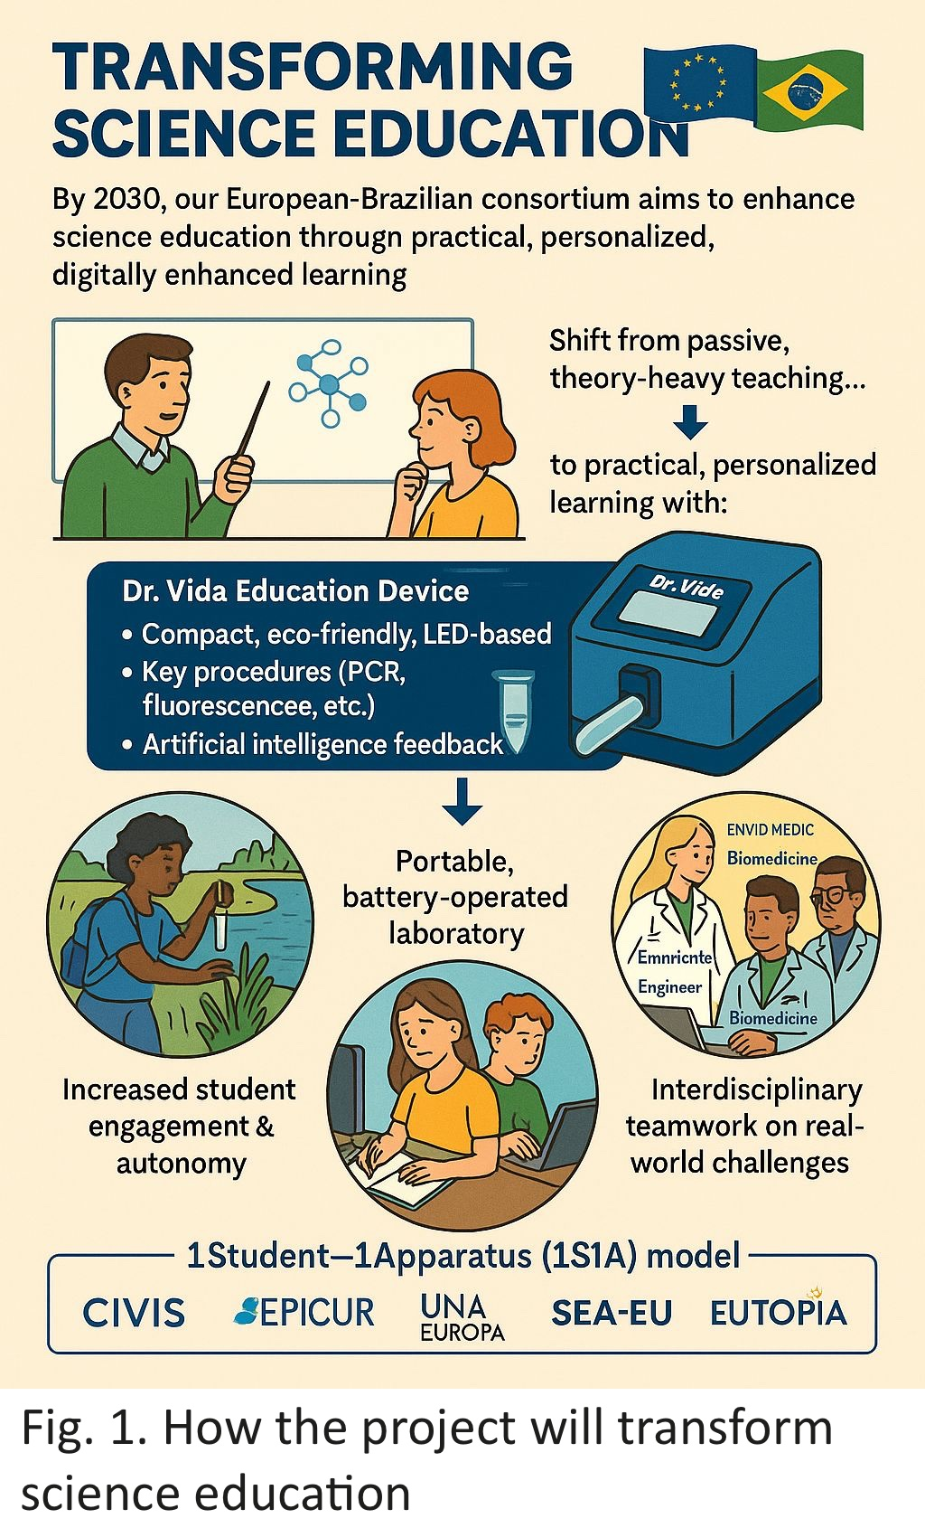

**Table A: Description of Alliance of Alliances + Brazilian Universities.**

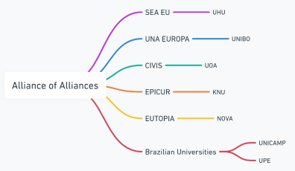

| [**EUTOPIA: NOVA**](https://www.unl.pt/eutopia/), alongside University of Warwick (UK), Vrije Universiteit Brussel (Belgium), CY Cergy Paris Université (France), University of Gothenburg (Sweden), Pompeu Fabra University (Spain), Technische Universität Dresden (Germany), Ca’ Foscari University of Venice (Italy), Babeș-Bolyai University (Romania), and University of Ljubljana (Slovenia). [**EPICUR: TSNUK**](https://epicur.edu.eu/?utm_source=chatgpt.com), alongside University of Strasbourg (France, coordinator), Adam Mickiewicz University in Poznań (Poland), Albert-Ludwigs-Universität Freiburg (Germany), Aristotle University of Thessaloniki (Greece), University of Amsterdam (Netherlands), Karlsruher Institut für Technologie (Germany), University of Natural Resources and Life Sciences in Vienna (Austria), University of Haute-Alsace (France), and University of Southern Denmark (Denmark). [**CIVIS: UOA**](https://civis.eu/), alongside Université libre de Bruxelles (Belgium), Universidad Autónoma de Madrid (Spain), Aix-Marseille Université (France), Sapienza Università di Roma (Italy), Eberhard Karls Universität Tübingen (Germany), University of Glasgow (UK), University of Bucharest (Romania), and Stockholm University (Sweden). CIVIS also includes associated partner institutions such as the University of Lausanne (Switzerland), Université Hassan II de Casablanca (Morocco), University of the Witwatersrand (South Africa), and University of Chile (Chile). [**UNA Europa: UNIBO**](https://site.unibo.it/una-europa/en)**, alongside** Freie Universität Berlin (Germany), KU Leuven (Belgium), Université Paris 1 Panthéon-Sorbonne (France), University of Edinburgh (UK), Jagiellonian University in Kraków (Poland), Universidad Complutense de Madrid (Spain), University of Leiden (Holland), University College Dublin (Ireland), and the University of Zurich (Switzerland) as an associate partner. [**SEA-EU: UHU**](https://sea-eu.org/), alongside University of Cádiz (Spain, coordinator), University of Western Brittany (France), University of Gdańsk (Poland), University of Kiel (Germany), University of Split (Croatia), University of Malta (Malta), University of Algarve (Portugal), University of Naples Parthenope (Italy), and Nord University (Norway). Brazilian Universities: **UPE&UNICAMP,** alongside University of São Paulo, Federal University of Rio de Janeiro – UFRJ, Federal University of Minas Gerais – UFMG, São Paulo State University – UNESP, Federal University of Rio Grande do Sul – UFRGs, Federal University of Santa Catarina – UFSC, Federal University of Paraná – UFPR, University of Brasília – UnB. |
| --- |

**Policy Alignment:** European & Brazilian Priorities: The project is fully aligned with the EIT HEI Initiative and several key policy frameworks in Europe and Brazil, addressing innovation, inclusion, and sustainability in higher education as follows: **(i)** [**European Green Deal:**](https://commission.europa.eu/strategy-and-policy/priorities-2019-2024/european-green-deal_en)Dr. Vida Education follows the analytical minimalism concept, minimizing environmental footprint while ensuring accurate scientific outcomes. This aligns with [Brazil’s Rede UniSustentável](https://redeunisustentavel.com.br/), the GreenMetric ranking, and Green Campus initiatives promoting sustainable operations in universities. **(ii)** [**EU Digital Education Action Plan (2021–2027):**](https://education.ec.europa.eu/focus-topics/digital-education/plan) Through AI and bioinformatics, Dr. Vida Education supports personalized and data-driven learning. This mirrors Brazil’s innovation in hybrid education led by [UNIVESP](https://univesp.br/) and the [Federal Institute of Ceará (IFCE)](https://ifce.edu.br/), which integrate sustainability and entrepreneurship in their digital learning ecosystems. **(iii)** [**European Skills Agenda:**](https://employment-social-affairs.ec.europa.eu/policies-and-activities/skills-and-qualifications/european-skills-agenda_en) The project contributes to upskilling and reskilling efforts in digital and scientific domains, particularly in data literacy, laboratory autonomy, and problem-solving. **(iv)** [**European Council’s Recommendation on Key Competences for Lifelong Learning:**](https://education.ec.europa.eu/focus-topics/improving-quality/key-competences) Dr. Vida Education enhances competences in digital literacy, science and technology, and entrepreneurship. This vision is echoed by Brazil’s [Associação Porto Digital](https://www.portodigital.pt/), a thriving innovation hub that connects academia, startups, and public institutions to build capacity for digital transformation.

**Impact and Reach (Table B):** By 2030, the project aims to implement Dr. Vida Education in at least 49 European HEIs and 14 global HEIs, including 10 universities in Brazil. Through innovation boot camps, international workshops, staff exchange programs, and conference participations, as well as through one startup, the project will ensure the dissemination and long-term sustainability of its results. These actions will be further reinforced by the NOVA-FCT-Bioscope network, which already organizes 13 international scientific conferences every two years ([www.bioscopegroup.org/conferences](http://www.bioscopegroup.org/conferences)), offering an ideal platform for showcasing outcomes, recruiting collaborators, and engaging external stakeholders. In summary, this initiative harnesses the collective intelligence, mobility infrastructure, and digital integration capacity of the “Alliance of Alliances” to revolutionize science education and foster lasting within-EU and EU–Brazil cooperation in education, research, and innovation.

**Knowledge Innovation Communities (KICs)**:

**EIT Health**: By integrating bioinformatics tools and supporting epidemiological studies, the device contributes to advancements in medical education and research, addressing critical global health challenges.

**EIT Climate-KIC**: The device’s eco-friendly design and applications in sustainability (e.g., water contamination monitoring) align with goals to tackle climate change through innovation.

**Table B. SMART-A2 Project's IVAP: Phases, Actions | Objectives, and respective SMART characteristics.**

| **Phase** | **Action | Objective** | **S**pecific | **M**easurable | **A**chievable | **R**elevant | **T**ime bound |
| --- | --- | --- | --- | --- | --- | --- |
| **Phase 1**  **(2026-2030)**  **Foundation and Pilot Implementation** | **1**  Develop and Integrate the Device into Beneficiaries´ Curricula | Pilot program with beneficiaries | At least 40 teachers and 1500 students involved in first phase | Experts Consortia | Practical science education | Full Integration by the end of 2027 |
| **2**  Build an Innovation Network within European Alliances | Building **SMARTUP** a Startup on Education | Education program extended to at least 8 HEIs | Utilize UNL-BIOSCOPE Conferences & expertise to promote and train | Collaboration between HEIs and Alliances | **SMARTUP** fully operational by the end of Phase 1 |
| **Phase 2**  **(2027-2030)**  **Expansion and Impact Enhancement** | **3**  Scale Adoption Across European Alliances and Brazil | Expand the program to 63 HEIs across America/Asia | At least 200 teachers and staff and 10000 students involved in third phase | Utilize HEIs Alliances infrastructure | Promotes Europe-wide educational and research sharing and transformation | Complete scaling by the end of 2029 |
| **4**  Foster sharing HEIs Skills | Boot camps for learning | Promote the hands-on training of 240 teachers and staff | KIC partners for mentoring and funding | Aligns with enhancing employability | Boot camps operational by last semester of 2027 |
| **Phase 3**  **(2026-2030)**  **Institutionalization and Global Outreach** | **5**  Institutionalize the Program | Institutionalize the Program | Integrate the device into the core curricula of at least 63 HEIs in Europe/America/Asia | Insert into degree accreditation standards | Long-term systemic change in education | Institutionalization completed by the end of 2029 |
| **6**  Strengthen Global Partnerships | Program globalization | Collaborations with at least 14 universities out of Europe | Foster Europe’s leadership in educational innovation | Expands Europe’s impact on global education | Partnerships working by the end of 2027 |

**1.2. Coordination and/or support measures and methodology** #@CON-MET-CM@# #@COM-PLE-CP@#

**1.2.1 Overall methodology and concepts**

Beyond pedagogical innovation, SMART-A2 includes a dedicated pillar for *upskilling R&I personnel*, including research managers, technicians, data stewards, laboratory support staff and early-career researchers. Through targeted mobility, peer-learning exchanges, and micro-training modules, partners will strengthen their institutional capacities in research management, open-science implementation, data stewardship, AI-assisted research workflows, and knowledge-valorisation processes. This responds directly to Module 2 of the EEI call (‘Upskilling of research, technical and management staff’) and reinforces the long-term excellence of widening-country HEIs.Science education programs in Europe and Brazil are often criticized for being overly theoretical, limiting students’ preparedness for real-world [applications](https://www.iop.org/sites/default/files/2019-09/practical-work-in-science.pdf?utm_source=)[1]. Many institutions prioritize traditional, knowledge-heavy teaching over practical, hands-on learning, constrained by limited resources, large class sizes, and regulatory frameworks such as [REACH](https://eur-lex.europa.eu/legal-content/en/ALL/?uri=CELEX%3A32006R1907&utm_source). Northern European countries like Finland and Sweden have successfully integrated experiential learning, achieving a better balance between theory and practice. In contrast, institutions in Southern and Eastern Europe, as well as many in Brazil, face significant resource limitations, resulting in [curricula](https://publications.lib.chalmers.se/records/fulltext/203607/local_203607.pdf?utm_source=) that lack sufficient laboratorycomponents[2]. In Brazil, São Paulo State dominates the R&D landscape, accounting for 46% of the national GERD and 66% of business R&D investment. However, a divide remains between research-intensive universities, which often emphasize theory, and teaching institutions, which may provide more practical training, albeit inconsistently. Reports such as the European Commission’s [Science Education for Responsible Citizenship](https://op.europa.eu/en/publication-detail/-/publication/a1d14fa0-8dbe-11e5-b8b7-01aa75ed71a1?utm_source=) (2015) and UNESCO’s *Global Education Monitoring* ([GEM](https://gem-report-2023.unesco.org/)) reports highlight the urgent need for inquiry-based and experiential learning to enhance scientific literacy. Despite the Bologna Process, implementation across Europe remains fragmented. National studies in countries like Germany and the UKconfirm[3] that many science graduates feel underprepared for laboratory-based careers due to inadequate hands-on training during their studies. While virtual labs and interdisciplinary fields like bioinformatics offer alternative training platforms, they cannot fully replace real laboratory experience. Addressing these challenges requires curriculum reforms that promote a true balance between theory and practice, supported by modernized laboratories, [smaller](https://www.hks.harvard.edu/sites/default/files/Academic%20Dean%27s%20Office/Guide%20to%20Small-Group%20Learning.pdf) lab groups (ideally one student per group), and comprehensive faculty training. **To bridge these gaps, science education must align with** [**EU**](https://europass.europa.eu/en/europass-digital-tools/european-qualifications-framework?utm_source=) **and** [**UNESCO**](https://uis.unesco.org/en/topic/international-standard-classification-education-isced?utm_source=) **educational frameworks, enhance the use of technology, and foster institutional partnerships through the exchange of teaching, technical, and administrative staff. Systemic reforms are essential to ensure graduates are equipped with the practical skills required for today’s scientific workforce.** In addressing these challenges, our team has developed a prototype of an **affordable yet powerful small device referred to as** [**Dr. Vida Education**](https://smartupdreducation.wixsite.com/welcome)**,** which offers a transformative solution. This device integrates UV and visible LEDs for molecule excitation and supports measurements of both fluorescence and phosphorescence. In addition, Dr. Vida Education presents the functionality of a compact **PCR system**, and the possibility of applications in **analytical, bioanalytical, and clinical biochemistry**. Additionally, its adaptability and transportability make it suitable for **environmental studies** (e.g., *in situ* pollutant monitoring) and **clinical medicine research** (e.g., point-of-care diagnostics), and also for bioinformatics and electrical engineering applications. Such a tool directly addresses gaps in hands-on scientific training by providing teachers and students with access to cutting-edge technologies at a fraction of traditional costs, with one unit costing less than 1000 euros. Its compact design and limited cost ensure that even resource- and space-constrained institutions can offer robust experimental opportunities to students, which is remarkable for developing countries and remote areas. **What is more important, for the first time a 1 student** – **1 apparatus (1S1A) concept can be achieved, allowing personalized learning and teacher-student interaction through improved experimental classes.** The device supports environmental studies by monitoring pollutants such as heavy metals and organic contaminants in water, soil, and air, enabling real-time environmental monitoring for conservation and compliance. In clinical fields, its compact PCR functionality facilitates on-site diagnostics for diseases, while fluorescence-based diagnostics aid biomarker detection and therapeutic decisions. Industrial applications include quality control in pharmaceuticals, food, and cosmetics, as well as process optimization. Dr. Vida Education also advances public health education by enabling disease surveillance and pathogen tracking in remote areas. **Its affordability and portability democratize access to quality science education, particularly in under-resourced regions, promoting STEM careers and equitable access to advanced tools.** The **Innovation Vision Action Plan (IVAP, Table B)**  ensures that strategic actions address critical challenges in European and Brazilian science education. The findings of the HEInnovate self-assessment directly informed the selection of actions within the IVAP.Curriculum design focuses on embedding Dr. Vida Education into multidisciplinary courses to bridge theoretical and practical learning. Faculty development workshops enable educators and academic staff to interchange educational skills, ensuring effective integration of the device. A phased rollout plan enables the scaling of the device adoption across **all members of the Alliance of Alliances, summing a total of 49 European HEIs, plus 14 global HEIs including 10 universities from Brazil.** Collaboration hubs facilitate knowledge sharing and technical support, and **international** partnerships are fostered to promote global collaboration.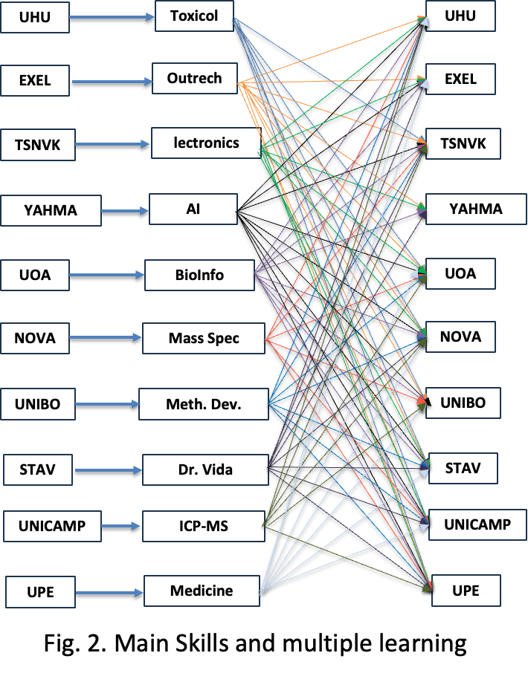

The integration of expertises and methods from different disciplines is central to achieving the objectives outlined in this project. This is reflected in Fig. 2 and Table C. Each type of teacher, technician and student involved with any of these degrees: (Bio)informatics, Chemistry or Biochemistry, Environment, Pharmacy, Medicine and Biomedicine, Physics and Electrical Engineering will bring unique skills and perspectives that will be harmonized to foster interdisciplinary collaboration and innovation,as depicted in Table D. In this project, teachers, technicians and students will apply their unique expertises via **Dr. Vida Education** and actively teach and learn from one another, fostering a collaborative and interdisciplinary approach. This knowledge exchange ensures a deeper understanding of complex challenges and promotes holistic problem-solving while promoting the integration of the **Alliance of Alliances.** All the Universities involved in this project have chosen degree programmes suitable for the implementation of the concept of Dr. Vida Education. The coordinators of the beneficiary institutions will bring together a comprehensive and interdisciplinary skill set that spans all scientific and technological areas required for the project’s success. This well-distributed and thematically integrated expertise positions the consortium optimally to address complex challenges at the interface of science, technology, education, and societal needs, while fostering impactful and sustainable innovation. During this project teachers, technicians and students will be distributed into multidisciplinary teams to conduct educational changes through the following laboratory works.

**1. Protein Analysis in Urine: Biochemistry teachers/students** prepare calibration curves to quantify urinary proteins; **medical teachers/students** discuss clinical implications for kidney disease, multiple myeloma; **bioinformatics teachers/students** automate data analysis using Python. Non-academic staff implement self-testing units to reduce bureaucracy. **2. Environmental Impact of Bacteria and Inorganic Pollutants: Environmental teachers/students** detect pharmaceutical residues in water; **pharmacy teachers/students** assess chemical stability; **bioinformatics teachers/students** model pollutant dispersion using AI. Targets include **Hg**, **As**, and **bacterial contamination**. **3. PCR Diagnostics for Public Health: Medical and Biomedical teachers/students** demonstrate PCR diagnostics; **biochemistry teachers/students** explain DNA amplification; **bioinformatics teachers/students** analyze epidemiological data. Case studies: **lactose intolerance screening, *Salmonella* and *Legionella* screening.**

**4. LED-Based Instrumentation: Engineering and physics teachers/students** assemble and explain the Dr. Vida Education; **(Bio)informatics, Chemistry or Biochemistry, Environment, Pharmacy teachers/students** demonstrate its use in analytical labs, highlighting modularity and field applicability. In the first year, **eight experimental practices** will be conducted. **Urine** will serve as the primary sample, using **simulated urine** for clinical applications. For large-scale data interpretation, **public datasets** will be used to train students in cohort analysis. Furthermore, a dedicated research work package will **investigate the pedagogical impact** of using the **Dr. Vida Education** for molecular biology education by conducting **controlled classroom trials, training workshops, and longitudinal studies**. These activities will examine how hands-on digital experimentation—such as **PCR-based simulations**—enhances **conceptual understanding, scientific reasoning, and engagement** across different educational levels. This approach bridges disciplines, fostering collaboration and practical skill development. AI Robustness and Trustworthiness: As part of Task 2.2 (see below), all AI-enabled features in **SMART-A2** using the Dr. Vida Education platform—including automated feedback, basic pattern recognition in student results, and quality checks that support teachers—will be developed following a clear, risk-proportionate robustness framework. Because these tools operate in a low-risk educational environment, focus will be on reliability, transparency and controlled behaviour rather than complex autonomy. Each AI module will be validated with pilot data from several universities to ensure accuracy and reproducibility, and the system will flag uncertainty or potential errors so teachers and students will be able to understand when results should be interpreted with caution. The tools will remain socially robust by being shaped around the real teaching contexts encountered during the co-design sessions in the first months, ensuring they support—not replace—educator judgement. All processing will follow GDPR obligations, with strict minimisation of personal data and a data-protection impact assessment conducted from the start. Whenever the AI influences feedback or progression insights, the system will provide simple, accessible explanations so that users can understand why a suggestion or prompt was generated. This approach guarantees that the AI operates safely, avoids unintended harm, safeguards the well-being of students, and remains fully aligned with the project’s educational mission and institutional requirements.

**Table C. Learning outcomes (LeO) and skills (Sk) fostered by Dr. Vida Education for different groups of teachers/technicians/students**

| **Teacher, technician and student** | **Learning Outcomes (LeO) and Skills (Sk)** |
| --- | --- |
| **(Bio) Informatics** | **LeO:** Deep Programming (LabVIEW, MATLAB, Python), Signal Processing Software (MATLAB, Python, Octave), and Data Visualization Tools (Python, MATLAB, Tableau, and Excel). **Sk**: How to Interface Electronic Devices with Computers, Printers, and Mobile Devices. Hands-On Laboratory Work. |
| **(Bio) Chemistry** | **LeO:** Spectrophotometry, Fluorescence, Quality Control, Preconcentration, Analytical Separations, Experimental Error, Statistics, AI, Python, Chemical Measurements, and Kinetics. **Sk**: Deep Concepts of Analytical and Bioanalytical Chemistry. Hands-On Laboratory Work. |
| **Environment** | **LeO:** Water and Wastewater Management. Analysis of Pollutants (Metals and Organics), AI, Python, and Chemical Measurements. **Sk**: Management of water and wastewater. Hands-On Laboratory Work. |
| **Pharmacy** | **LeO:** Spectrophotometry, Fluorescence, Quality Control, Preconcentration, Analytical Separations, Experimental Error, Statistics, AI, Python, Chemical Measurements, Pharmacokinetics, Drug Analysis, and PCR. **Sk**: Analysis of Drugs and Metabolites, Hands-On Laboratory Work. |
| **Medicine and Biomedicine** | **LeO:** Epidemiology, PCR Applications, Case Studies, Statistics, AI, Python, and Chemical Measurements. **Sk**: PCR Analysis, DNA and Medicine, Statistics for Epidemiology. Hands-On Laboratory Work. |
| **Physics and Electrical Engineering** | **LeO:** Electronic Components and Assembly. Epidemiology, PCR Applications, Case Studies, Statistics, AI, Python, and Chemical Measurements. **Sk**: PCR Analysis, DNA and Medicine, Statistics for Epidemiology, Spectrophotometry, Fluorescence, Quality Control, Preconcentration. Hands-On Laboratory Work. |

**Table D. Integration of Expertise Through Staff Interchange and Peer Teaching: Some examples.**

| **(Bio) Informatics** | **What They Can Teach**: Data acquisition, processing, and visualization techniques using tools such as Python, MATLAB, and Tableau. Advanced signal processing methods to refine and analyze experimental data generated in chemistry, pharmacy, or environmental studies. **What They Can Learn**: From **Biochemistry**: The importance of proper experimental setup, such as designing accurate calibration curves for spectrophotometric data. From **Medicine**: How processed data can be used to extract meaningful clinical insights, such as identifying patterns in epidemiological studies or biomarker analyses. |
| --- | --- |
| **(Bio) Chemistry** | **What They Can Teach**: How to create and validate calibration curves for quantifying analytes, such as total proteins in urine or pollutants in water. Experimental techniques for preconcentration, separations, and analytical error minimization, which can be applied in pharmacy, environmental studies, or medical diagnostics. **What They Can Learn**: From **Medicine**: The clinical significance of chemical measurements, such as the relevance of protein concentration in diagnosing kidney disease. From **Bioinformatics**: How to automate data processing and visualize complex datasets for more efficient analysis. |
| **Environment** | **What They Can Teach**: Methods for water and wastewater analysis, including pollutant quantification (e.g., metals and organics) and the use of AI for environmental monitoring. Insights into the ecological and health impacts of pollutants, offering context for pharmaceutical and medical applications. **What They Can Learn**: From **Pharmacy**: How to analyze the environmental persistence and degradation of pharmaceutical compounds. From **Biochemistry**: Techniques for detecting and quantifying pollutants using advanced analytical tools, such as fluorescence and spectrophotometry. |
| **Pharmacy** | **What They Can Teach**: Pharmacokinetics and drug metabolism, helping medical students and biochemists understand how drugs are absorbed, distributed, metabolised and excreted. Techniques for analyzing metabolites and validating the accuracy of drug testing protocols.  **What They Can Learn**: From **Medicine**: The clinical context of drug efficacy and safety, and how pharmacokinetic data informs treatment decisions. From **Environment**: The impact of pharmaceutical waste on ecosystems and how to develop environmentally friendly drugs. |
| **Medicine and Biomedicine** | **What They Can Teach**: The clinical relevance of data, such as the medical significance of protein levels in urine or the implications of pollutant exposure on public health. How to link epidemiological data with chemical measurements to draw meaningful conclusions about population health. **What They Can Learn**: From **Bioinformatics**: Techniques to handle large datasets, such as epidemiological studies, and derive actionable insights through AI and statistical modeling. From **Biochemistry**: The chemical and bioanalytical foundations of diagnostic tools, such as PCR and fluorescence-based assays. |
| **Physics and Electrical Engineering** | **What They Can Teach:** Design and optimization of diagnostic technologies, including signal processing, microfluidics, embedded systems, and hardware for biosensors and wearables; modeling of energy transfer and material interactions in analytical tools.What They Can Learn:From Bioinformatics: Data handling and AI-driven analysis of large datasets. From Biochemistry: Foundations of techniques like PCR and fluorescence assays. From Medicine: Clinical interpretation of chemical data and links between exposure and health outcomes. |
| **Non- Academic Staff** | Through job shadowing, short-term training, technical visits, and workshops, non-academic staff will participate in **practical knowledge exchange**. Lab technicians will **train in equipment maintenance**(e.g., *Dr. Vida Education*), develop safety protocols, and support joint experiments. IT staff will focus on integrating digital platforms, managing experimental data, and implementing AI tools. **Administrative staff** will work on harmonising mobility processes, managing project finances, and tracking impact indicators. Educational support staff will create tutorials and assist teachers and students in using digital tools effectively. |

The project integrates the Knowledge Triangle—education, research, and business—by embedding the Dr. Vida Education device into higher education curricula to equip students with practical skills aligned with EU lifelong learning priorities. Collaborations among institutions such as UHU, NOVA, UOA, UNIBO, UNICAMP, UPE, TSNUK and STABV ensure the device remains innovative and impactful across disciplines, while partnerships with industry, STABV and YAGHMA, facilitate market readiness, business model development, and commercialization. EXEL ensures dissemination and communication. TSNUK maintains technological updates of Dr. Vida Education. The NOVA´s robust [Diversity and Inclusion Action Plan](https://www.unl.pt/en/noticias/nova/nova-university-lisbon-implements-gender-equality-plan/?utm_source=chatgpt.com) **prioritizes gender equality** and representation and will be implemented throughout the project. **UHU, UNIBO and UPE are led by females, NOVA is led by a non-binary person.** Outreach to underrepresented groups, including students from immigrant backgrounds and less-developed regions, will help ensure equitable access. Designing gender-sensitive tools for inclusivity in the lab, combined with the Dr. Vida Education device, will ensure fair use of **education** and healthcare applications.Monitoring gender balance throughout the project ensures accountability and continuous improvement. This approach aligns with [**UN SDG 5 (Gender Equality)**](https://sdgs.un.org/goals/goal5) andthe [**EU Gender Equality Strategy 2020-2025**](https://ec.europa.eu/info/policies/justice-and-fundamental-rights/gender-equality/gender-equality-strategy_en), reinforcing the project's sustainability and impact. The affordability and portability of the device enable access in resource-limited contexts or remote regions, such as Brazil, Ukraine, Portugal and Greece, promoting equity in science education. The project’s IP strategy, guided by a Consortium Agreement, defines ownership and use while ensuring open access to research outputs. A GDPR-compliant Data Management Plan supports secure, transparent data handling, with protocols for collection, sharing, and storage. This comprehensive plan ensures long-term accessibility and reproducibility, reinforcing the project’s alignment with sustainability and innovation goals.

**1.2.2 Coordination and support measures**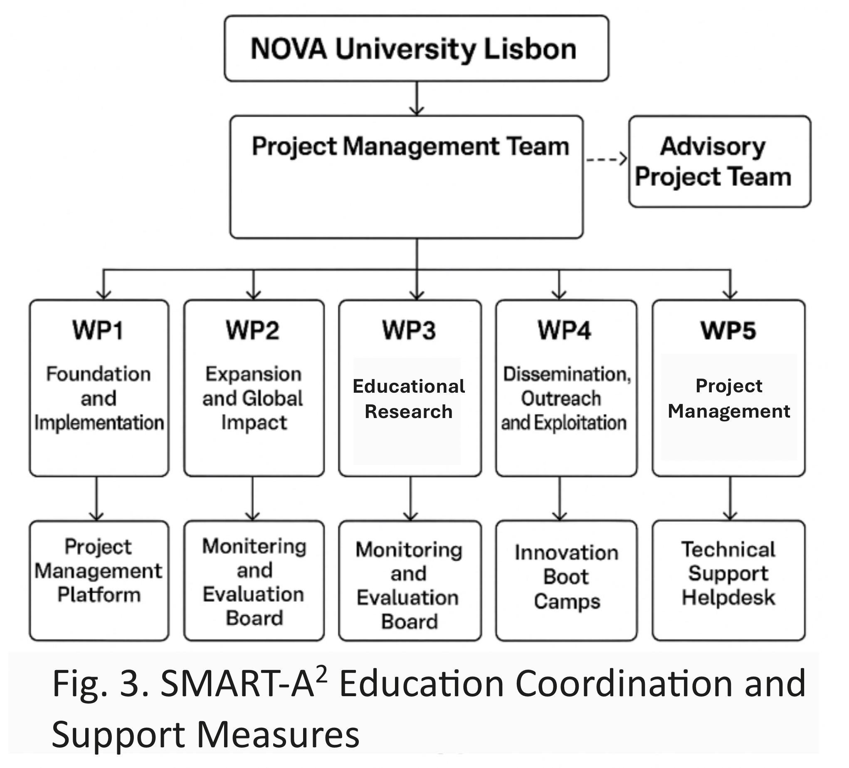

Several European-funded projects, such as [**OpenAIRE**](https://www.openaire.eu/)and [**Scientix**](https://www.scientix.eu/), serve as inspirations for this initiative. These projects promote open science, collaborative learning, and STEM education across Europe, aligning closely with the goals of the SMART-A2 project. Additionally, the [**Bologna Process**](https://education.ec.europa.eu/education-levels/higher-education/inclusive-and-connected-higher-education/bologna-process) provides a framework for harmonizing higher education across Europe, influencing the curriculum redesign strategies proposed in this project. The project employs a **matrix coordination structure** to ensure effective delivery of objectives, combining centralized management with distributed action-specific leadership.

The **SMART-A2** project is supported by a strong coordination and governance framework designed to ensure effective management, seamless collaboration among partners, and timely delivery of its ambitious objectives, as shown in Fig. 3. The structure combines centralized coordination with decentralized implementation, allowing the multidisciplinary expertise and regional diversity of the consortium to achieve educational transformation, scientific advancement, and sustainable innovation.

The project is coordinated by **NOVA University Lisbon (Portugal)**, which leads both WP1 (Foundation and Implementation) and WP5 (Project Management). NOVA is responsible for ensuring strategic alignment, administrative efficiency, and scientific integrity across all work packages. A dedicated **Project Management Team (PMT)**—composed of **José Luís Capelo, Hugo Santos, Carlos Lodeiro**, and **Elisabete Oliveira (Portugal)**—oversees the day-to-day coordination, financial management, reporting, and communication between all partners, ensuring coherence and accountability. The PMT also manages the Consortium Agreement and Intellectual Property Rights (Task 5.3), guaranteeing transparent governance, compliance with EU standards, and secure data handling. An **Advisory Project Management Team (Advisory PMT)**—including **Makis Zoidakis (Greece), Laura Mercolini (Italy),** and **Tereza Cartaxo (Brazil)**—supports the coordination activities with strategic, scientific, and pedagogical input. This advisory team ensures integration between educational and research components, provides risk mitigation advice, and supervises adherence to gender equality and open science principles. Decentralized leadership ensures that each WP benefits from expert oversight by the most qualified institution. **WP2 (Expansion and Global Impact)** is led by UPE (Brazil), **WP3 (Educational Research)** by UNIBO (Italy) in collaboration with STABV (Portugal), **WP4 (Dissemination, Outreach and Exploitation)** by EXEL (Greece), and **WP5 (Project Management)** by NOVA (Portugal). The **Work Package Coordinators (WPCs)**—**José Luís Capelo (NOVA), Dimitris Raptis (Exel), Laura Mercolini (UNIBO),** and **Tereza Cartaxo (Brazil)**—guarantee coherent progress, regional coordination, and methodological consistency across all thematic areas. This distributed structure ensures ownership, responsiveness, and effective adaptation to local contexts. Efficient communication and coordination are supported by a comprehensive set of tools and procedures. A **Project Management Platform (PMP)** will serve as a central hub for documentation, budgeting, scheduling, and key performance indicator (KPI) tracking. Regular **quarterly WP meetings** and **annual General Assemblies** will review progress, address deviations, and update the implementation strategy. A **central digital archive** will store all official documents, meeting records, and deliverables, ensuring full transparency and traceability. A **Technical Support Helpdesk** will be established to assist partner institutions with device deployment, calibration, and troubleshooting. Each higher education institution (HEI) will also implement its own **Innovation Vision Action Plan (IVAP)**, tailored to its academic structure and national context, to embed the “**1 Student – 1 Apparatus (1S1A)**” model and support institutional innovation. **Staff mobility and capacity building are at the core of the support framework.** The project will organize regular **faculty development workshops** to train educators in the pedagogical and technical use of the Dr. Vida Education device and associated software. These sessions will promote digital pedagogy, interdisciplinary learning, and data-driven teaching methods. All training activities will be recorded and made available through the project’s web portal to ensure continuous access. Additionally, **Innovation Boot Camps** (Task 2.3) will train more than 240 educators in Europe, South America, Africa and Asia. **Monitoring and quality assurance** are ensured through a dedicated **Monitoring and Evaluation Board (MEB)** composed of WP leaders and Advisory PMT members. The MEB will supervise milestones (Table 3.1d), deliverables, and risk management (Table 3.1e). A **Gender and Inclusion Oversight Group**, coordinated by NOVA (Portugal), will ensure equitable participation and monitor diversity metrics throughout the project’s implementation. Risks related to technical performance, partner engagement, and regulatory compliance will be mitigated through redundancy in partner expertise, transparent communication, and GDPR-compliant data practices. **The digital infrastructure** of the project supports collaboration, open learning, and sustainability. The **SMART-A2 Dr. Vida Education Web Portal** (Task 2.2) will assemble educational resources, experimental protocols, open-source analytical tools, and AI-assisted guidance systems for students and teachers. Artificial intelligence modules will provide adaptive learning support, automated feedback, and real-time data visualization, enhancing personalized education and fostering innovation in STEM learning. **Institutionalization and sustainability** beyond the project’s duration are key priorities. The creation of the **SMARTUP startup** (Task 1.3), coordinated by NOVA (Portugal), will ensure the continuity of the Dr. Vida Education device’s technological development, market deployment, and pedagogical adaptation. The **curriculum integration frameworks** developed in Task 2.4 will align the device and learning modules with HEI accreditation requirements, ensuring long-term adoption. A comprehensive **Exploitation Strategy** (Task 4.3) will support the identification of new funding opportunities, intellectual property valorization, and the expansion of Dr. Vida Education use across global academic networks. **Project governance** is further reinforced through a **Project Steering Committee (PSC)** composed of representatives from all partner institutions, meeting quarterly to review progress and strategic alignment. The PSC includes **José Luís Capelo (NOVA), Tereza Cartaxo (UPE), Marco Aurélio Zezzi Arruda (UNICAMP), Michalis Zoidakis (UOA), Tamara Garcia-Barrera (UHU), Laura Mercolini (UNIBO), Oleg Olikh (TSNUK), Orfeu Flores (STABV), Yagma (YAGHMA)**, and **Dimitrios Raptis (EXEL)**. **External guidance and quality assurance** are provided by an independent **Scientific and Educational Advisory Board (SEAB)** comprising leading international experts: **Magdalena Biesaga (Poland), Manuel Miró (Spain), Jacek Wisniewski (Germany), Pierre-Olivier Schmit (Germany)**, and **Masaru Miyagi (USA)**. The SEAB will meet annually to evaluate project performance, provide strategic recommendations, and ensure excellence across scientific, pedagogical, and technological dimensions. Through this coordinated and multi-level structure—combining centralized management, distributed leadership, continuous training, digital integration, and independent evaluation—the SMART-A2 project will ensure efficient implementation, accountability, and lasting impact within the European and global higher education landscape. The coordination framework directly supports (see table B) **Objective 1** (*Develop and Integrate the Device into Beneficiaries´ Curricula*) by embedding Dr. Vida Education into STEM programs and promoting hands-on learning. Strong governance structures also advance **Objective 2** (*Build an Innovation Network within European Alliances*), fostering collaboration across universities, research institutes, and industry. Ensuring equitable access supports **Objective 3** (*Scale Adoption Across European Alliances and Brazil*), enabling resource-constrained HEIs to benefit from this digital transformation, consistent with the [**European Skills Agenda**.](https://employment-social-affairs.ec.europa.eu/policies-and-activities/skills-and-qualifications/european-skills-agenda_en) Innovation boot camps and hands-on problem-solving activities advance **Objective 4** (*Foster sharing HEIs’ Skills*), providing researchers and students with real-world challenges and new technical competencies. Key barriers—such as limited lab infrastructure, faculty expertise, and funding—are addressed through **Objective 5** (*Institutionalize the Program*), which prioritizes faculty training and investment in experimental learning environments. The coordination design ensures teachers and students engage with cutting-edge tools for data collection, analysis, and visualization—contributing to **Objective 6** (*Strengthen Global Partnerships*) and aligning with the **EU** [**Digital Education Action Plan (2021–2027)**](https://education.ec.europa.eu/focus-topics/digital-education/plan) and the [**EIT Knowledge Triangle**,](https://www.eitmanufacturing.eu/what-we-do/the-eit-knowledge-triangle/) which links education, research, and innovation. Finally, these actions support adoption metrics under **Objective 3** and reflect the values of the [**European Commission’s Science Education for Responsible Citizenship**](https://op.europa.eu/en/publication-detail/-/publication/a1d14fa0-8dbe-11e5-b8b7-01aa75ed71a1/language-en) framework.

**1.2.3 Open Science Practices**

The **SMART-A2** project embraces Open Science as a central tenet, ensuring that research outputs and learning resources are freely available and co-created with end users. Key practices (Fig. 4) include (i) open access to all publications, learning modules, and device blueprints; (ii) use of preprints and open peer review to accelerate dissemination; (iii) open-source development of software and data analysis tools; (iv) FAIR-compliant data sharing in trusted repositories; (v) co-creation with students, teachers, and societal actors (e.g., through living labs and citizen science pilots); (vi) involvement in European open innovation ecosystems (e.g., EIT KIC networks) to promote replication and scaling; (vii) Zoom-based courses to rapidly engage the educational community; and (viii) presentations at international education conferences, including the biennial event organized by the NOVA team ([www.sciedu2025.com](https://sciedu2025.bioscopegroup.org)). This strong commitment to openness will ensure broad uptake and long-term sustainability of the project results. **A dedicated webpage already exists for Dr. Vida Education**, serving as the seed of the future open portal for disseminating all information and materials created through this project, including a short explicative video of the project (<https://smartupdreducation.wixsite.com/welcome>, password: SMART).

**1.2.4 Research data management and management of other research outputs**

All research data and educational outputs generated by the project will be managed in accordance with the FAIR principles—Findable, Accessible, Interoperable, and Reusable (see Fig. 4). Metadata will be structured using standard ontologies and deposited in public registries; data will be stored in institutional or EU repositories (e.g., Zenodo, OpenAIRE) with open access under CC BY or equivalent licenses; file formats will comply with community standards (e.g., CSV, JSON, XML) and will be fully documented to ensure reproducibility; and comprehensive documentation, version control, and licensing information will be provided to facilitate reuse by the community. **A Data Management Plan (DMP) will be submitted within the first three months** of the project and updated annually. NOVA will lead the DMP development, while the Project Steering Committee (PSC) will oversee its preparation and submission for approval to the Scientific and Ethical Advisory Board (SEAB), in coordination with all data-generating partners. Research outputs beyond data—including software, device protocols, and training materials—will be made openly available through the project’s dedicated web page 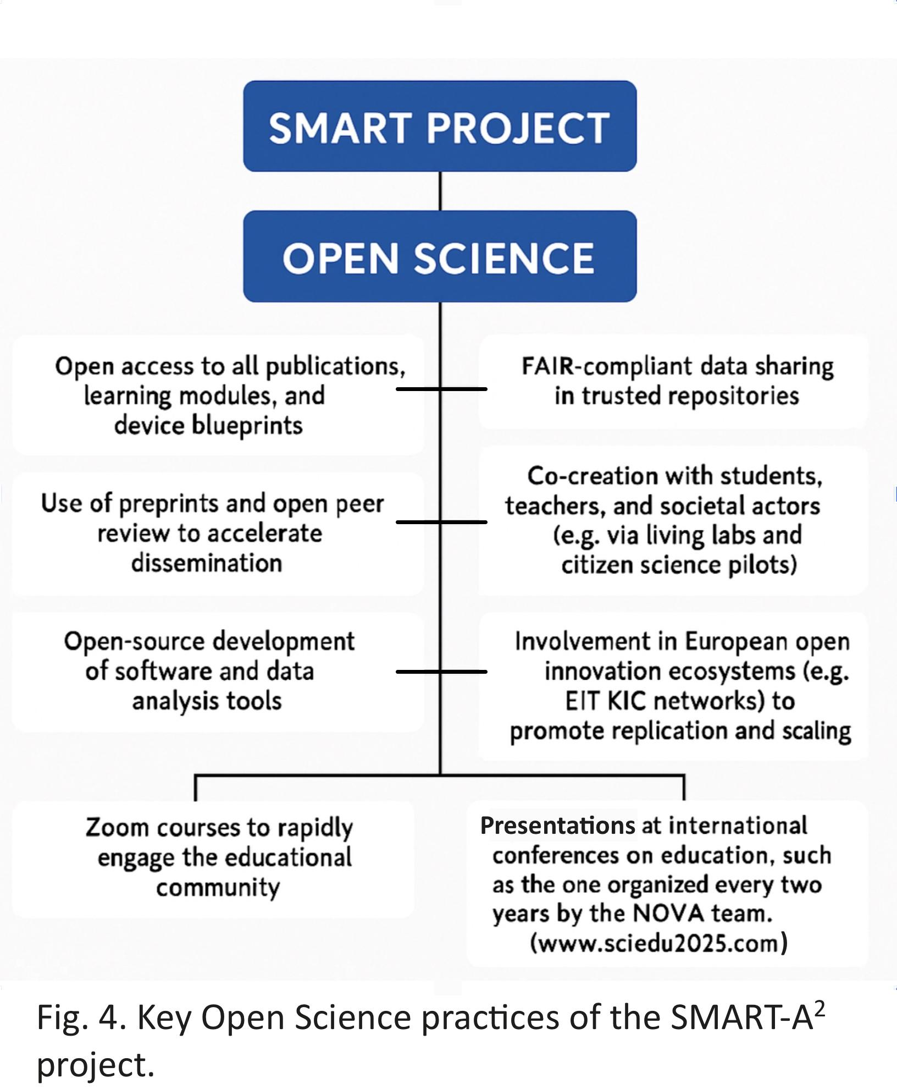

**2. Impact** #@IMP-ACT-IA@#

**2.1. Project’s pathways towards impact**

The **SMART-A2 project** revolutionizes science education by realizing the *one student – one apparatus* vision through the seamless integration of the **Dr. Vida Education device** into higher education curricula. Beyond transforming student learning, the project strengthens the **Alliance of Alliances** network by fostering meaningful collaboration among all participating universities — including the **Brazilian institutions** — within a coordinated framework of teaching and learning. This structure enhances the **mobility and compatibility of Erasmus exchanges**, benefiting not only students but also **academic, non-academic, and technical staff**. By promoting shared pedagogical standards, joint training initiatives, and transdisciplinary interaction across **49+4+10 HEIs**, **SMART-A2** deepens institutional cooperation and creates a cohesive, dynamic community of practice. Its unique contribution lies in embedding **hands-on, technology-enhanced learning** into theoretical education while building lasting networks that extend well beyond the project’s lifespan.

**Unique Contribution to Expected Outcomes and Wider Impacts**

**(i) Contribution to Outcomes Specified in the Topic**

**(i.1) Practical Education Revolution**: The project establishes a "1 student – 1 apparatus" model with Dr. Vida Education, allowing individualized, real-time experimental learning across disciplines like biochemistry, clinical diagnostics, environmental science, and bioinformatics. This directly contributes to Horizon Europe’s outcomes of fostering innovation capacity and improving science and technology education quality. **(i.2)** **Entrepreneurial and Digital Skills Training**: Through boot camps and curricula integration, students and educators gain hands-on skills in AI, data analysis, Python programming, and entrepreneurial problem-solving—advancing the EU’s Digital Education Action Plan and European Skills Agenda. **(i.3) Innovation Ecosystems**: The establishment of SMARTUP, a startup incubated within the project, exemplifies how academia-industry synergies can be fostered within HEIs. This supports the expected outcome of enabling HEIs to become central players in regional innovation ecosystems.

**All educational, technological and AI-enabled outputs of SMART-A2 are embedded in a broader institutional-reform pathway: they act as practical demonstrators for modernised R&I governance, open-science workflows, digital-R&I infrastructures, and updated research-assessment practices across widening HEIs. The primary long-term impact of SMART-A2 is therefore an upgrade of the R&I dimension of higher-education institutions, with the Dr. Vida Education pilots functioning as catalysts for structural modernisation, strengthened R&I careers, improved knowledge valorisation, and enhanced participation of widening institutions in Horizon Europe**

**(ii) Wider Long-Term Impacts**

**(ii.1) Institutional Change**:(i) The institutionalisation of Dr. Vida Education and experiential learning practices across 49+4+10 HEIs by 2030 will support structural reforms in higher education, the harmonisation of accreditation standards, and the efficient use of resources already mobilised by the Alliance of Alliances. (ii.2) Partnerships with 49+4+10 HEIs reinforce the EU–Brazil co-leadership in educational innovation and contribute to raising global standards in STEM education. (ii.3) The device’s affordability ensures equitable access in resource-constrained contexts (SDG 4, 5 and 10), while its low environmental footprint aligns with the Green Deal and sustainability targets. Beneficiary groups include teaching staff and students in Biochemistry, Medicine, Environmental Sciences, Pharmacy, Informatics, Physics and Engineering—especially in underfunded institutions; STEM educators implementing experiential and interdisciplinary teaching models; university leadership and curriculum boards adopting and accrediting the modules; EdTech startups and SMEs (STABV, YAGHMA); policy makers and accreditation agencies; European university alliances sharing educators and administrative staff; and secondary schools integrating Dr. Vida Education. The scale and significance of the project are as follows: (i) by 2027, 1500 students and 40 educators trained in 8 HEIs; (ii) by 2029, 10,000 students and 200 educators trained in 49+4+10 HEIs worldwide; (iii) by 2035, expansion to secondary-school teachers and international dissemination through webpages and conferences. This scale supports European-wide uptake and global adoption, enhancing employability, digital competencies and scientific literacy while promoting educational equity and innovation. **Quantifiable Effects**: +30% increase in student engagement, +40% improvement in practical learning outcomes, 1 new startup launched (SMARTUP), up to 500 educators trained in entrepreneurship and digital tools, and a transversal educational tool in all educational systems. Studies in STEM education demonstrate that hands-on learning and active experimentation can improve student engagement by 25–35% and practical skill acquisition by 30–50%[4],[5]. The individualized nature of the Dr. Vida Education device builds upon this foundation by ensuring full student access and autonomy, which is likely to amplify these documented benefits. The one-student-one-device approach eliminates common obstacles such as equipment sharing and passive observation, both of which have been identified in EU reports as detrimental to skill development ([EU Science Education Report, 2023](https://education.ec.europa.eu/it/news/education-and-training-monitor-2023-encouraging-trends-but-challenges-remain?utm_source)). This model supports personalized and repeatable experimentation, fostering deeper conceptual retention and greater student confidence. Furthermore, the integration of artificial intelligence tools, real-time feedback mechanisms, and bioinformatics functionalities facilitates adaptive learning pathways. This aligns with findings from the OECD EdTech [Review](https://www.aitsl.edu.au/research/spotlights/evaluating-the-evidence-for-educational-technology-part-1-the-technologies?utm_source), which indicate that digital interactivity significantly enhances both engagement and performance in laboratory-based educational settings.

**2.1.1 Scientific Impact**

The **SMART-A2** project is expected to generate substantial scientific and educational impact (see Fig. 5) by contributing to advances across and within multiple disciplines, particularly in the fields of analytical and bioanalytical chemistry, bioinformatics, molecular diagnostics, and science education. Through the development and deployment of the Dr. Vida Education device, the project will enable novel experimental methodologies that integrate fluorescence, UV-Vis, and PCR-based analysis **in a compact and affordable format.** These innovations will support new lines of inquiry in clinical diagnostics, environmental monitoring, and biochemical analysis. By embedding the device into practical teaching modules and interdisciplinary case studies (e.g., bioinformatics-driven pollutant modeling or epidemiological PCR diagnostics), the project fosters scientific literacy and cross-disciplinary research capabilities among students and educators. This aligns with broader EU goals to promote transdisciplinary research and bridge gaps between traditionally siloed fields such as medicine, data science, and environmental sciences.

The device itself reinforces scientific infrastructure by democratizing access to advanced instrumentation. It provides HEIs—including those in resource-limited regions—with reliable, modular, and scalable equipment that can be used both in educational and research contexts. Its compatibility with AI-powered analytics and real-time data acquisition further supports the development of intelligent computing systems within research environments. Moreover, by generating open-source protocols and datasets, and by incorporating the device into research-intensive curricula, the project will contribute to the co-creation of new scientific knowledge. The Dr. Vida Education device will also enable scalable pilot studies and exploratory research in small labs or classrooms, thus functioning as a platform for methodological innovation and early-stage discovery science. Ultimately, Dr. Vida Education will reinforce Europe’s and Brazil’s scientific infrastructure by strengthening both human capital and experimental capabilities across a diverse range of institutions by the interchange of knowledge and expertise.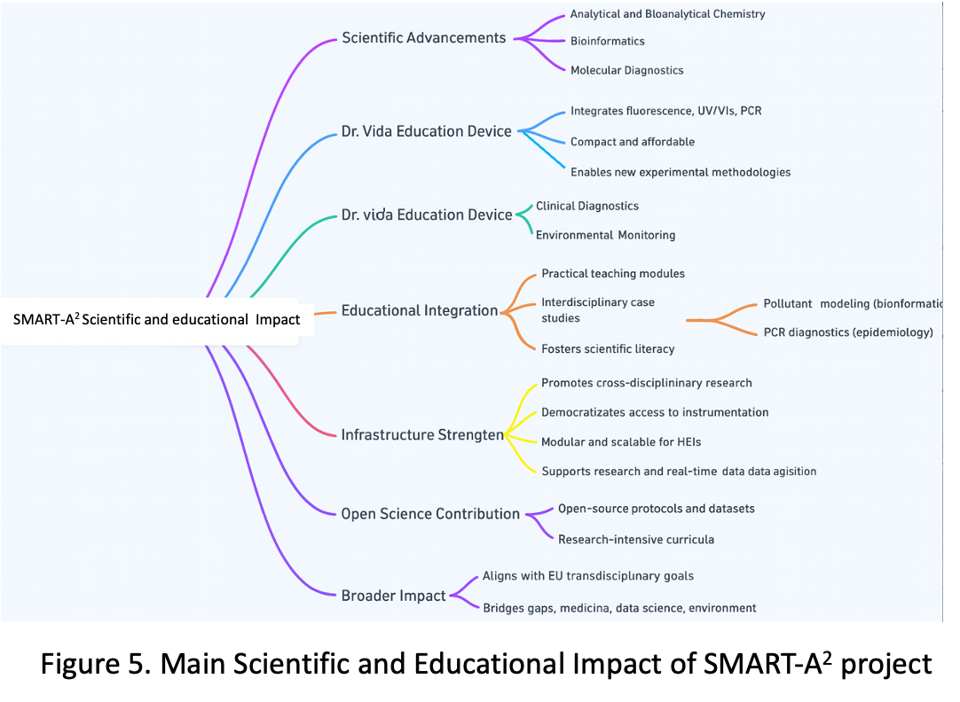

**2.1.2 Economic/technological impact**

The **SMART-A2** project will generate significant economic and technological impact by introducing a new educational technology into the market as a scalable, multifunctional, and low-cost solution for hands-on scientific learning. This innovation brings together several capabilities (e.g., UV-Vis, fluorescence, PCR) in a single compact unit, dramatically reducing the need for multiple, expensive laboratory instruments in higher education and training environments. Economically, the project lowers the financial barriers associated with practical science education. Traditional laboratory setups often require investments exceeding €20,000 per lab unit; in contrast, the Dr. Vida Education Education device is designed to deliver equivalent core functionality at a fraction of the cost, around €1,000. This increases access for under-resourced institutions and enables broader adoption across regions, particularly in developing countries where budget constraints are a limiting factor.

The project also promotes **staff mobility among the Alliance of Alliances**—including educators, technicians, and administrative personnel—**as a driver of institutional innovation.** By facilitating the exchange of personnel between partner institutions, the initiative accelerates the transfer of knowledge, best practices, and operational models. This not only improves institutional efficiency and reduces training costs but also helps harmonize technical standards and administrative procedures across borders. The movement of trained personnel fosters capacity-building and encourages the diffusion of technological and pedagogical innovations, generating spillover benefits in host and sending institutions alike. Technologically, the device integrates advanced features such as real-time data acquisition and AI-based analysis. These attributes not only support modern pedagogical models like blended and distance learning but also reflect industry-grade capabilities that prepare students for digitally enabled workplaces. In this way, the project accelerates the digital transformation of science education and strengthens the technological pipeline for sectors such as diagnostics, biotechnology, and environmental monitoring. The project also drives innovation in educational services and business models. Through the creation of the SMARTUP startup, the initiative will develop new distribution, support, and licensing mechanisms for the device, while also enabling future iterations and product extensions. Moreover, by training educators and researchers in how to apply and adapt the device—and mobilizing them across institutional and national contexts—the project contributes to a knowledge-based economy and supports entrepreneurial activity at the intersection of science, education, and technology.

**2.1.3 Societal Impact**

The **SMART-A2** project will generate meaningful societal impact by promoting equitable access to quality science education, advancing public health awareness, and contributing to environmental sustainability. Through the deployment of the Dr. Vida Education device, students and educators will be empowered with tools to explore and address real-world societal challenges, including pollution, disease monitoring, and sustainable development. In terms of **environmental impact**, the device promotes the principle of analytical minimalism, enabling accurate scientific analysis using fewer reagents by requiring microquantities, less energy, and more compact, eco-friendly equipment. Its use in teaching environmental chemistry and pollutant detection—such as monitoring heavy metals in water—raises awareness among teachers, students and other non-academics staff as well as local communities about environmental health risks, thereby supporting broader goals of decreasing CO₂ emissions and toxic exposure through informed behavior and better practices. It can be deployed in the field using batteries allowing in situ measurements. On the **public health front**, the device facilitates practical learning in areas such as PCR-based diagnostics and biomarker detection, enabling students to simulate or even participate in epidemiological surveillance projects. This contributes to increased health literacy and strengthens the capacity of future professionals to engage in preventive health strategies, ultimately supporting efforts to reduce avoidable mortality. Its application in case studies, such as lactose intolerance or sexually transmitted infections, fosters early understanding of societal health challenges and how data can guide decision-making. The development of a dedicated work package for **research in education** will contribute to **fostering the applicability of the 1A1S concept**. The project also fosters **policy improvement and awareness**, as students and faculty apply scientific evidence to real-world case studies. For example, bioinformatics modules that model environmental pollutant dispersion or disease outbreaks help simulate how scientific data informs policy and urban planning. These activities will be shared in public exhibitions and science fairs, contributing to **consumer and citizen awareness** on health and environmental issues. Importantly, by ensuring access to low-cost, high-impact educational tools across underserved regions, the project reduces educational inequality, supports gender equity, and aligns with United Nations Sustainable Development Goals, **4 (Quality Education), 5 (Gender Equality), 10 (Reduced Inequalities), 13 (Climate Action), and 3 (Good Health and Well-being).** The inclusion of underrepresented students in STEM training also contributes to building a more inclusive and scientifically literate society, better equipped to participate in and influence democratic decision-making on issues of health, climate, and innovation. We aim to move the 1S1A approach to medium schools after 2030.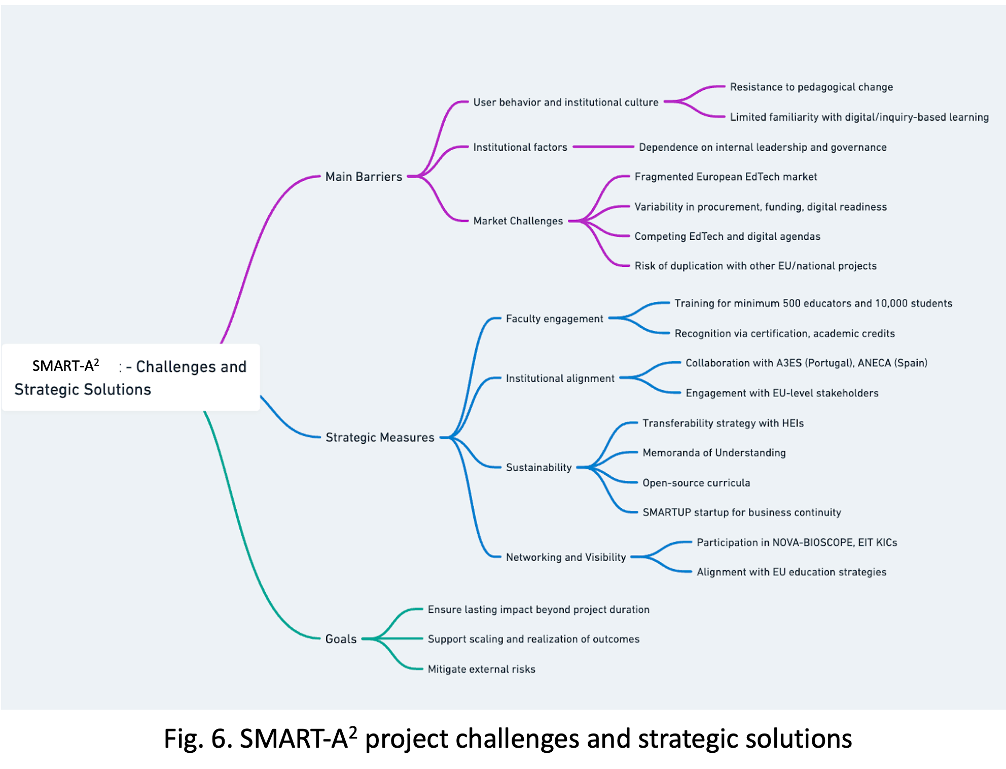

**2.1.4 Scale and significance**

The scale of **SMART** project’s expected outcomes is considerable, as the project targets structural transformation in science education across Europe and globally. The project aims to reach: **1500 students and 40 educators** during the pilot phase by the end of 2027 across 8 HEIs, **10000 students and 200 educators** in the expansion phase by the end of 2029 across 49+4+10 HEIs, and a secondary outreach impact (through open-access materials and dissemination) projected to influence up to **500+ educators/researchers/technicians/administrative staff** and **20,000+ students** by 2035 via conferences, boot camps, and digital platforms. The significance of these outcomes lies in their direct contribution to educational reform, equity, and skills development: an estimated **30% increase in student engagement** and **40% improvement in practical learning outcomes**, based on pilot data and studies; cost savings of up to **80% per experimental unit** compared to traditional lab setups, enabling resource-limited institutions to provide hands-on education for the first time; development of at least **one commercial startup (SMARTUP)**, creating new EdTech business models and contributing to regional innovation ecosystems; training of at least **500+ educators/researchers/technicians/administrative staff** and at least **20,000+ students** in entrepreneurship, AI, and data analysis, promoting workforce digital readiness; and contribution to **SDGs 3, 4, 5, 10, and 13** by enhancing access, inclusion, environmental awareness, and health literacy. Baselines and assumptions include: baseline engagement in practical learning is limited, as ~60% of HEIs in Europe report insufficient access to lab equipment or digital tools (EU Science Education Report, 2023); pilot studies conducted in Portugal (NOVA) and Italy (UNIBO) show that students using **Dr. Vida Education** report significantly higher satisfaction and confidence in applying scientific methods compared to control groups; cost comparisons are based on equipment market prices (traditional UV-Vis: €15,000–40,000; fluorescence modules: €8,000+; PCR systems: €10,000–25,000), while **Dr. Vida Education** aims to deliver integrated functionality at **<€1000/device** (visible, fluorescence, phosphorescence, PCR); and the extrapolation methodology uses pilot impact data from partner HEIs and projected adoption curves informed by comparable EU-funded education technology initiatives.All estimates refer exclusively to the SMART-A2 project and do not include or assume effects from other initiatives or ongoing reforms.

**2.1.5 Requirements and potential barrier.**

A primary barrier lies in user behavior and institutional culture, where resistance to pedagogical change, particularly among faculty unfamiliar with digital or inquiry-based learning, may slow adoption. Despite the project’s investment in faculty training and incentives, sustainable transformation often depends on internal leadership, governance support, and change management processes that extend beyond the project’s duration. Furthermore, the European EdTech market remains highly fragmented, with significant variability in procurement systems, funding availability, and digital readiness across regions. Even with an affordable solution, successful uptake may rely on institutional or national funding beyond the project’s lifetime, and attention may be diverted by competing educational technologies or digitalization agendas. In addition, parallel research and innovation initiatives under Horizon Europe or national schemes may target similar objectives in STEM education or AI-based learning, presenting both opportunities for synergy and risks of duplication or reduced visibility if not carefully managed. To mitigate these external risks, the project incorporates several measures. The **SMART-A2 project** benefits from the framework of the **Alliance of Alliances**, a transcontinental consortium connecting **55 universities**, including **European and Brazilian partners**, under a shared vision for the transformation of higher education. This structure enables the **sharing of human, technical, and pedagogical resources** across institutions, ensuring that teaching, training, and administrative staff can benefit from a **coordinated scheme of learning and professional development**. Such coordination facilitates **compatibility and reciprocity in Erasmus exchanges**, while also deepening institutional collaboration and reducing duplication of effort across regions. By using the shared infrastructure of the **Alliance of Alliances**, the project overcomes limitations related to regional disparities in digital readiness and access to equipment. This collective resource pool supports the continuous dissemination, adaptation, and mutual reinforcement of the SMART-A2 methodology, ensuring its scalability beyond the original consortium. In addition, the SMART-A2 project includes continuous collaboration with national educational societies and EU-level stakeholders to ensure alignment with evolving educational standards. A **transferability and institutionalization strategy**, supported by Memoranda of Understanding with higher education institutions and the development of open-source curricula, will help maintain the project’s impact beyond its funding period. The establishment of the **SMARTUP startup** during the project provides a sustainable business model for production, support, and further development of the device independently of EU project cycles. To address user behavior, the project trains at least **500 educators** and implements recognition mechanisms such as **certification, academic credits, and EU-level visibility** to embed experiential teaching approaches into institutional practice. Finally, by actively engaging international networks such as those provided by the **NOVA BIOSCOPE group**, **EIT KICs**, and the **Alliance of Alliances**, and by aligning with broader EU education strategies, the project ensures both visibility and complementarity with related initiatives. Together, these measures are designed to anticipate and buffer against external uncertainties, supporting the continued scaling and realization of SMART’s intended outcomes and impacts well beyond the formal end of the project.

**2.2. Measures to maximise impact – Dissemination, exploitation and communication** #@COM-DIS-VIS-CDV@#

**2.2.1 Dissemination, exploitation and communication**

To ensure the maximum impact of the SMART-A2 project, it is crucial to effectively communicate its findings to the relevant target audiences and stakeholders. This will be achieved through a comprehensive approach centered on dissemination, exploitation, and communication. EXEL, a highly experienced SME in managing high-profile EU research projects, will lead this effort, which is coordinated under a dedicated work package (WP4). The strategy is designed to foster awareness and engagement both during and after the project’s execution. A detailed plan outlining these activities will be prepared early in the project, specifying actions to enhance the project's visibility and reach.

**2.2.1.1 Internal Communication**

The **SMART-A2** consortium ensures continuous and dynamic communication through a variety of channels, facilitating the seamless exchange of information, insights, and updates. By drawing on the shared infrastructure and expertise of the Alliance of Alliances, like digital tools such as **virtual meetings**, **video conferencing**, andcollaborative **online platforms**, partners can engage efficiently across diverse locations and time zones. This communication framework integrates formal elements—such as the dissemination of official progress reports and documents—with informal interactions like **team chats**. This balanced approach fosters transparency and inclusivity, strengthening R&I human capital while improving collaboration across sectors. To further promote cooperation and cross-sectoral collaboration, **SMART-A2** organises regular **consortium meetings**, both online and in person. These meetings are critical for deep discussions, problem-solving, and ensuring alignment with the project's overall objectives. Task-specific meetings are also scheduled to drive focused progress, particularly supporting the enhancement of excellence in Widening countries.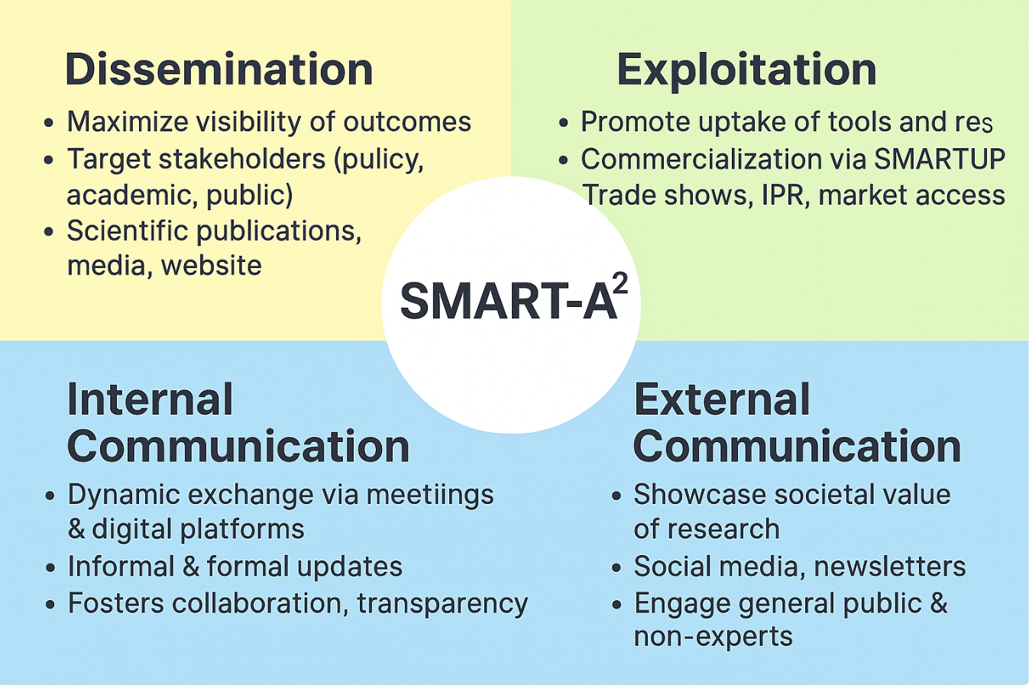

**2.2.1.2 Dissemination strategy**

The dissemination strategy for the **SMART-A2** project will be meticulously designed to ensure the effective communication of its results, discoveries, and achievements to a wide scientific audience and beyond (Table 1). Aligned with the project’s goal of fostering institutional reforms, reversing brain drain, and enhancing knowledge circulation, this strategy will begin by identifying **key stakeholders** (Table 2) and developing **targeted approaches** to engage diverse audiences, including policymakers, industry leaders, academics, and the general public. Leveraging a mix of traditional and digital channels—such as press releases, academic publications, social media, and a dedicated **project website**—the plan aims to maximise the visibility and impact of **SMART-A2**’s outcomes.

Dissemination efforts will support key outcomes, including strengthening collaboration between academic and non-academic sectors, and improving private sector access to public R&I institutions and infrastructures. Key activities include: (1) Maintaining **SMART-A2**'s strong presence at relevant scientific and industry **forums**, **conferences**, and **symposia**, to showcase the project’s innovations and promote excellence in Widening countries; (2) Producing and distributing **newsletters**, **brochures**, and **infographics** to effectively communicate project progress and achievements to a wide range of stakeholders; (3) Engaging with the **media** to highlight **SMART-A2**’s contributions, increasing the project’s visibility across sectors and regions; and (4) Organising **workshops** and **webinars** to disseminate findings, enhance cross-sector collaboration, and promote entrepreneurial skills among participants. These comprehensive efforts aim to position **SMART-A2** as a driving force for impactful collaborations between academic and non-academic sectors, while enhancing the employability and career prospects of R&I talents. A detailed stakeholder engagement plan (part of D4.3) will ensure that the project’s findings are communicated effectively to the right audiences. To maximise impact, the commercial potential of results will be evaluated prior to publication, and all contributions from the EC will be duly acknowledged.

Additionally, **SMART-A2**’s results and tools will be presented at four major trade shows in the USA, Europe, and MENA, further strengthening the R&I base, promoting talent mobility, and improving career opportunities across both academic and non-academic sectors. Through these efforts, **SMART-A2** aims to leave a lasting legacy of knowledge, innovation, and capacity-building.

**Table 1: Indicative list of platforms for disseminating SMART-A2’s advancement**

| **International Conferences and Trade Shows** | International Caparica Conference on Science Education, 2025, 2027, 2029, 2031, 2033, 2035; International Caparica Conferences, Bioscope group 2026-2035 (already programmed, total of 57);NAFSA conferences; The European Conference on Education; European Association for International Education series; FENESP-Brazil; FETC-USA |
| --- | --- |
| **Scientific Journals** | Review of Educational Research; Journal of integrated OMICS (from Bioscope group); Educational Researcher; International Journal of Educational Technology in Higher Education; Studies in Science Education; Talanta; Communications Medicine |

**Table 2: List of stakeholders**

| **Stakeholder Groups** | **Identified entities** |
| --- | --- |
| Governmental institutions | National Ministries of Education via departments for Higher Education. National Research Councils and Innovation Agencies. Health Ministries and Health institutions. Introducing the SMART-A2 project at the K-12 level or in regional universities. |
| Regulators | National Agencies for Accreditation and Quality Assurance: <https://www.a3es.pt/> | <https://www.aneca.es> | <https://www.nvao.net/en> | https://www.qaa.ac.uk |
| Scientific community | STEM (Science, Technology, Engineering, Mathematics) education specialists. Analytical and Bioanalytical Sciences Community. Biomedical Sciences Community. Physics and electrical engineers. Universities, medium schools. |
| Innovator community | Global innovation ecosystems like the **EIT KICs** (e.g., EIT Health, EIT Raw Materials). NGOs working on education accessibility in underserved areas. Medium schools. |

**2.2.2.2 Communication Plan**

Through targeted and inclusive communication efforts, **SMART-A2** seeks to highlight the tangible impact of EU-funded research and innovation on everyday life. This strategy enhances knowledge circulation, strengthens public-private collaborations, and increases awareness of the societal value of research.

Table 3 outlines a comprehensive outreach plan designed to increase R&I support capacity, foster cross-sector collaboration, and engage the public and stakeholders. A strong digital presence and active use of social media will enhance visibility, while newsletters, press releases, and outreach materials will ensure continuous communication of the project's objectives and milestones. Scientific dissemination through conferences and publications will contribute to research excellence, while workshops and events will promote knowledge exchange and collaboration, supporting the balanced circulation of talent across sectors and regions.

**Table 3: Outreach Activities**

| **Activity** | **Description** | **Timing** | **Lead** | **Metrics** | **Target Audience** |
| --- | --- | --- | --- | --- | --- |
| **Digital Presence** | | | | | |
| Project Website | Central Hub for **SMART-A2** Updates and Resources. | From M3, ongoing | EXEL | >2000 visits/year | General public, researchers, stakeholders, medium schools |
| Social Media | Engage with updates on project platforms: Facebook, X, LinkedIn, and Instagram. | From M2, ongoing | EXEL | Followers: X: 1500; LinkedIn: 800; Instagram: 300 | General public, industry, policymakers, researchers |
| **Outreach Materials** | | | | | |
| Visual Identity | Designing of logo, letterhead, and presentation templates | M1 | EXEL | 5 templates | Consortium, stakeholders |
| Brochures & Leaflets | Distribution of detailed visuals about goals and benefits | M2, updated regularly | EXEL | 2 flyers, 2 roll-ups, 2 posters | Industry, policymakers, public, researchers |
| **Content Engagement** | | | | | |
| Newsletters | Distribution of electronic updates to stakeholders | 4/year | EXEL | >200 subscribers | Industry, policymakers, researchers, public |
| Press Releases | Highlighting significant milestones to the media, utilising professional global services, e.g., EIN Presswire | At major milestones | All | >5 releases | Media, general public, industry, policymakers |
| **Scientific Communication** | | | | | |
| Conferences | Sharing findings with the scientific community | After research results | All | 100 presentations | Researchers, industry experts, policymakers |
| Publications | Publishing findings in scientific journals | After research results | All | 20 publications | Researchers, academics, general public |
| **Events** | | | | | |
| Workshops, boot camps | Promoting **SMART-A2** and fostering collaborations | Annually | All | 80 workshops/boot camps | Researchers, industry, policymakers, public |
| Closing conference | Final event to share outcomes and enhance stakeholder interactions | M56 | NOVA | 1 conference | Researchers, policymakers, industry, general public |

**2.2.1.3 Networking and Training Activities**

To foster sustainable capacity-building and institutional integration of experiential STEM learning, the **SMART-A2** project embeds a structured program of networking and training activities. These efforts are strategically aligned with the international calendar of the NOVA-Bioscope group, which hosts recurring conferences across Europe through 2026 to 2035 and beyond (57 till 2035). **Training Integration:** The project capitalizes on over six to seven annual international scientific conferences (at least 57 conferences in 10 years), <https://www.bioscopegroup.org/conferences/>, as real-world platforms for training a minimum of 300 educators in experiential pedagogy, digital tools, and inquiry-based learning (estimation of 5% of total conference attendees). Educators are invited to co-develop and present educational innovations, supported by academic recognition mechanisms (certificates, credits, and EU-level visibility). In addition to in-person training, the project implements a comprehensive **online training framework** hosted through the **SMART-A2** Dr. Vida Education website. This includes asynchronous modules, webinars, and virtual workshops on device usage, classroom integration, and assessment strategies. These resources ensure equitable access to training regardless of geographic location, promoting wide-scale adoption and institutional embedding. The web-based platform also supports continuous peer exchange, resource sharing, and tracking of certification progress. **Networking for Impact and Visibility:** These conferences also serve as critical nodes for multi-level networking, enabling direct engagement with policy makers, institutional leaders, and EU education stakeholders. Through partnerships facilitated at these events, **SMART-A2** ensures alignment with university and medium school needs and synergies with Horizon Europe and EIT KIC initiatives. **Sustainability through Community and Exchange:** By anchoring the project’s activities within the NOVA-Bioscope group, network until 2035, **SMART-A2** secures continuity for its community of practice beyond the formal funding period. This sustained engagement strengthens the project's institutionalization strategy and supports the international scaling of its educational model through the SMARTUP startup.

**2.2.2 IPR management**

The project will implement a **hybrid IP strategy** that balances open access with targeted protection. Educational protocols and non-commercial training materials will be released under **open-source licenses** to promote accessibility and collaboration. In parallel, **formal IP protection** will cover the Dr. Vida Education device, including its hardware design and electronic components, through **utility models and/or design rights**, selected according to patentability and cost-effectiveness. Software modules will be protected by copyright, while core algorithms may be kept as **trade secrets**. The project’s visual identity and branding will be secured through trademark registration under the **SMARTUP startup**. A **DESCA**-based Consortium Agreement will clearly define ownership of background and project results, rules for joint ownership, and access rights required for implementation and exploitation. It will also outline licensing options—non-exclusive academic use and exclusive commercial licenses—along with mechanisms for dispute resolution and revenue sharing. Each partner will retain ownership of their background IP while granting necessary access rights. The exploitation strategy includes the **creation of the SMARTUP startup** as the commercial vehicle for the Dr. Vida Education device. All protected project results will be licensed or transferred to SMARTUP under the conditions defined in the CA. In parallel, open-access resources such as curricula and experimental protocols will be made publicly available on a dedicated platform under **Creative Commons licenses**, ensuring broad educational uptake while maintaining brand visibility and reputation. In line with Horizon Europe IPR requirements, a comprehensive Results Ownership List will accompany the final periodic report, detailing the ownership of all results and supporting transparent, long-term exploitation planning. This integrated IP management approach safeguards key innovations, ensures openness where appropriate, and supports lasting impact and sustainability for the SMART-A2 project. #§COM-DIS-VIS-CDV§#

**2.3. Summary**

**KEY ELEMENT OF THE IMPACT SECTION**

| **SPECIFIC NEEDS** | **EXPECTED RESULTS** | **D & E & C MEASURES** |
| --- | --- | --- |
| Many HEIs—especially in Widening regions—lack affordable, scalable laboratory equipment, limiting hands-on science training. This structural gap reduces student engagement, weakens STEM learning, and prevents systematic adoption of experiential teaching. A key unmet need is the “one student – one apparatus” model, which guarantees individual access to experimental tools; without it, learning remains passive and unequal, hindering practical skill development, scientific literacy, and employability. | By 2030, the project aims to train **10,000 students** and at least **200 educators** worldwide, and to institutionalize the Dr. Vida Education model in **49+4+10 HEIs**. Beyond these numbers, it seeks to drive a paradigm shift in science education by embedding hands-on, in situ experimentation into theoretical classes and promoting shared teaching practices. This approach strengthens active learning, improves conceptual understanding, and links theory to real-world applications. Dr. Vida Education will also support additional tasks in health and environmental monitoring in widening or remote regions, and its adoption is expected to extend to medium schools by 2030–2035. Overall, more than **500 staff** and **20,000 students** are expected to be involved by 2030. | Exploitation will include commercialisation of the Dr. Vida Education device through the SMARTUP spin-off, protected by design rights and utility models, with licensing options for HEIs and open-source curricula and protocols released under Creative Commons. Dissemination will occur via peer-reviewed publications, international conferences (SEFI, EARLI, EIT summits), educator workshops, policy briefs to accreditation bodies (A3ES, ANECA), and promotion through the NOVA-BIOSCOPE network, EU platforms, and Horizon Europe clusters. Communication to citizens will be carried out through the project website ([**https://smartupdreducation.wixsite.com/welcome**](https://smartupdreducation.wixsite.com/welcome) — Pass: **SMART**) and social media ([**https://smartupdreducation.wixsite.com/welcome/social-media**](https://smartupdreducation.wixsite.com/welcome/social-media)), complemented by public demonstrations, school events, and short documentary videos. |
| **TARGET GROUPS** | **OUTCOMES** | **IMPACTS** |
| **In addition to the involved HEIs, beneficiaries of this project will be the following ones:** Alliances totalling 49+4+10 universities: EUTOPIA, EPICUR, CIVIS, UNA Europa, SEA-EU + Brazilian Universities (10). Universities and Medium Schools all over the world via access to the web page and to share hands-on and knowledge. | The Alliance of Alliances—including EUTOPIA, EPICUR, CIVIS, UNA Europa, and SEA-EU—extends the SMART-A2 project’s impact across Europe, with at least 45 HEIs, particularly in Widening countries, expected to adopt the Dr. Vida Education device and protocols. This promotes a “one student – one device” model that strengthens STEM pedagogy, curricula, and teacher training. SMART-A2 also supports EU goals in sustainability and on environmental and public-health topics, fostering scientific literacy and community resilience. The project further enhances mobility of educators and staff. | **Scientific**: SMART-A2 establishes a scalable, evidence-based model for integrating hands-on experimentation into STEM education, validating the effectiveness of the “one student – one device” approach. **Economic/Technological**: By commercialising a modular, low-cost teaching device and creating a dedicated startup, the project strengthens the EU EdTech ecosystem, drives innovation, and supports job creation in high-tech educational sectors. **Societal**: It improves science literacy and digital competence among teachers and students—especially in Widening countries—by ensuring inclusive access to advanced learning tools, promoting equitable and gender-balanced STEM participation, and empowering underserved communities. The project aligns with SDGs 3, 4, 5, 10, and 13, fostering informed, engaged, and sustainability-aware citizens. |

**3. Quality and Efficiency of the implementation** #@QUA-LIT-QL@# #@WRK-PLA-WP@#

**3.1. Work plan and resources**

SMART-A2 fully complies with the widening requirement of the European Excellence Initiative call. The centre of gravity of the action lies in Widening countries, and at least 51% of the total eligible budget is allocated to beneficiaries in Portugal, Greece and Ukraine. These partners coordinate the institutional modernisation, digital-R&I transformation and capacity-building components of the action. Non-widening partners act as excellence mentors supporting the transfer of advanced R&I practices and digital expertise into the widening R&I ecosystems.

**Table 3.1a – List of work packages**

| **WP No** | **WP Title** | **Lead Participant No** | **Lead Participant Short Name** | **Person Months** | **Start Month** | **End Month** |
| --- | --- | --- | --- | --- | --- | --- |
| 1 | **Foundation and Implementation** | 1 | NOVA | 113.3 | 1 | 60 |
| 2 | **Expansion and Global Impact** | 9 | UPE | 128 | 12 | 60 |
| 3 | **Educational Research** | 2 | UNIBO | 85.7 | 3 | 60 |
| 4 | **Dissemination, Outreach and Exploitation** | 6 | EXEL | 90 | 1 | 60 |
| 5 | **Project Management** | 1 | NOVA | 81.5 | 1 | 60 |

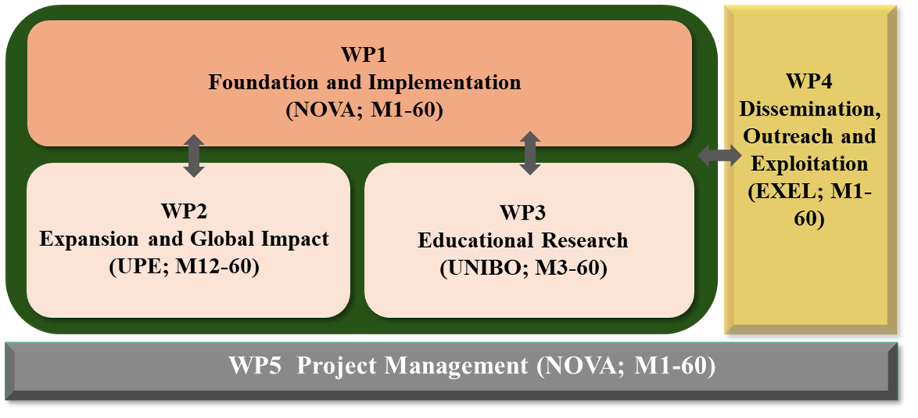

**SMART-A2 Pert Chart**

**Table 3.1b – Work package description**

| **Work Package number** | **1** |
| --- | --- |
| **Work Package title** | **Foundation and Implementation** |
| **Objectives:** WP1 focuses on **implementing the Dr. Vida Education device into pilot curricula** across eight participating academic institutions, engaging by the end of 2026 over 800+ students and 24+ teachers in eight hands-on laboratory modules that integrate real-time data collection and analysis into STEM teaching (all beneficiaries). This rollout serves as a foundation for evaluating pedagogical effectiveness and institutional integration of Alliances. Concurrently, the project initiates the **development of an advanced prototype** of the Dr. Vida Education device (STABV) featuring a **touchscreen interface** and **UV detection capabilities, in addition to a calibration system (TSNUK)**. This next-generation system is designed to expand experimental possibilities in health and environmental monitoring, while enhancing usability for both students and educators in field and classroom contexts. | |
| **T1.1 – Digital transformation of Dr. Vida Education and Green Lab Learning [M1-21] (Lead: NOVA;** Contributing: ​​STABV, UNIBO, UNICAMP, UPE, UOA, UHU, EXEL,YAGHMA**)** | |
| As part of the SMART-A² initiative, and powered by the Alliance of Alliances, this phase of the project focuses on finalizing the Dr. Vida Education, transforming the current prototype into a fully operational, screen-based digital tool. This shared effort is driven by the consortium’s diverse institutional strengths and educational traditions, fostering collaborative innovation across borders. In parallel, the project will redesign and harmonize eight laboratory practices based on green bioanalytical minimalism—a framework that reduces reagent use and minimizes environmental impact. These carefully selected, hands-on experiments will include: (i) total protein quantification in urine for kidney disease detection, and (ii) for myeloma disease, (iii) extraction and analysis of mercury in water, and (iv) arsenic in water, (v) bacterial contamination in water, (vi) lactose intolerance detection, (vii) *Salmonella* detection, and (viii) *Legionella* detection, both in water (with treated non dangerous samples). Together, these practices offer an interdisciplinary, real-world learning experience in health and environmental science. **Crucially, all members of the Alliance of Alliances—spanning Europe, Brazil, and Africa—will actively exchange skills and methodologies through staff mobility, becoming mutual trainers and testers**. This model ensures that each institution not only teaches but also learns from the others, reinforcing peer-to-peer innovation across the alliance. The finalized version of the Dr. Vida Education will integrate a comprehensive description of all eight lab practices, including statistical tools; an open-source digital interface that guides both teachers and students through experiments and data interpretation; structured questionnaires and AI-driven self-assessment tools to enhance reflection and pedagogical feedback. By embedding AI into both experimental guidance and student evaluation, SMART-A² ensures that educational innovation is both scalable and personalized. The Alliance of Alliances thus becomes the foundation of a co-created, sustainable, and pedagogically rich STEM learning ecosystem—fostering scientific literacy, green practices, and institutional reform across regions. **(D1.1a, D1.1b)** | |
| **T1.2 – Evaluating Learning Outcomes of Dr. Vida Education-Enabled Lab Activities Across Institutions [M1-27] (Lead**: **YAGHMA**, Contributing: UNIBO, UNICAMP, UPE, UOA, UHU**)** | |
| Focuses on testing and validating the laboratory activities developed in Task 1.1 in practical classes, targeting 1500 students across the eight academic beneficiary institutions. Statistical analyses will be conducted to evaluate student success across the projects and institutions. Techniques include descriptive statistics, ANOVA, regression models, and machine learning to identify performance patterns and predictors. This comprehensive framework will assess the device's impact on learning outcomes and provide data-driven insights to refine educational practices, ensuring the success of the pilot phase and laying the foundation for broader implementation. **(D1.2).** | |
| **T1.3 – Creating SMARTUP startup to Lead in Educational Technology [M1-60] (Lead: NOVA,** Contributing: UNIBO, UNICAMP, UPE, UOA, YAGHMA**)** | |
| The establishment of the SMARTUP startup, centred around the Dr. Vida Education device, represents a transformative step toward modernizing science education. It aims to develop an innovative, scalable, and adaptable solution that promotes personalized learning, enhances student engagement, and integrates digital tools across multiple educational levels by integrating teacher interaction. A dedicated PhD researcher will be recruited to lead research and development activities, assess the device's pedagogical effectiveness, and ensure its alignment with evidence-based educational methodologies. **(D1.3).** This role will encompass data-driven optimization of the device, integration into curricula, development of intellectual property strategies, and international networking to position **SMARTUP as a reference in educational technology and learning among EU and Brazilian HEIs. (D1.4). Beyond 2030, the PhD and consortium partners will spearhead the global expansion of SMARTUP, utilizing opportunities such as the Europe-Mercosur treaty to reach broader educational markets and foster cross-continental collaboration via staff mobility.** | |

| **Work Package number** | **2** |
| --- | --- |
| **Work Package title** | **Expansion and Global Impact** |
| **Objectives:** The second phase scales the adoption of Dr. Vida Education approach to the members of the alliances: Each beneficiary will engage in the project up to 2 national HEIs collaborators integrated in the Alliances taking part in this study, targeting a minimum of 3 teachers and 125 students per HEI (a minimum of 2000 students, 16 HEIs + 48 educators). **The final phase institutionalizes the Dr. Vida Education program across the other 39 HEIs** (completing the list of 49+4+10 HEIs involved in this alliance, at least 10000 students and at least 200 teachers, including Brazil). (See Table E). Key activities include the following tasks: | |
| **T2.1 – 1st expansion. Expanding Dr. Vida education to further HEIs [M12-36] (Lead: UPE;** Contributing: NOVA, UNIBO, STABV, UOA, EXEL, UNICAMP, YAGHMA, TSNUK, UHU) | |
| Engaging a total of 16 HEIs and a total of 48 educators and at least 2000 students. These educators will be trained in the laboratories of their respective national beneficiaries or via the internet (e.g.: Zoom). **(D2.1). (See table E).** Each beneficiary engages 2 national HEIs. A significant checkpoint will be the agreement of 16 HEIs to implement the Dr. Vida Education approach. | |
| **T2.2 – Development of web-based tools [M17-30] (Lead: YAGHMA;** Contributing: UNICAMP, UNIBO, STABV, UOA, EXEL, UNICAMP, TSNUK, UHU, UPE**)** | |
| Development of web-based tools in the **SMART Dr. Vida Education** web page so the practices developed in work package one and the statistics results are available to the Alliance of Alliances' educational community and world wide. **(D2.2)** From month 1 to 2 we will sit with research managers, librarians and researchers to turn policy goals (open science and fairer research assessment) into simple user journeys. From month 2 to 6 we’ll build the first version and connect it to each university’s existing systems (e.g., log in once with your university account, pull in your ORCID profile, push deposits to your repository). Between months 6 and 10 we’ll run two pilot rounds at a minimum of four universities—at least two in Widening countries—to fix usability issues, tighten security and make the workflows faster. By months 11–12 we will release a beta, hand over an admin guide and API notes, and train local support staff so they can run it without us. By the end of the year, researchers will be able to record contributions for narrative CVs, deposit publications/data/software in one guided flow, and register and track small seed projects end-to-end—with clear audit trails. We aim for active use in four universities, at least 200 outputs deposited, and smooth single sign-on everywhere. The main risks are slow IT integrations, low initial uptake and privacy concerns; we manage these with early test environments, co-design and a data-protection impact assessment from the start. All AI-enabled features of the web-based tools—such as automated feedback, quality checks and simple learning analytics—will follow the robustness principles outlined in Section 1.2.1, ensuring reliability, transparency, and proportional risk management throughout development. | |
| **T2.3 – Learning Innovation Boots Camps [M13-60] (Lead: NOVA**; Contributing: UNICAMP, UNIBO, STABV, UOA, EXEL, UNICAMP, YAGHMA, TSNUK, UHU, UPE**)** | |
| Launching innovation boot camps aims to train a minimum of 500 educators across Europe and South America linked to the Alliance of alliances, thus stimulating staff mobility. From 2027 to 2030, two boot camps will annually be done by each beneficiary institution (48 in total, three days each, 5 participants minimum per camp). These immersive programs equip teachers and technical staff with skills to integrate the Dr. Vida Education device and modern teaching methodologies, enhancing student engagement and personalized learning. The curriculum covers innovative pedagogy (information developed in task 1.2), technology adoption (Dr. Vida Education implementation), and practical applications (The 8 practices developed in task 1.1), thus fostering a network of educators as ambassadors for Dr. Vida Education. This ensures scalability and sustainability by embedding these tools into everyday teaching, bridging traditional and modern education for lasting impact. **(D2.3).** | |
| **T2.4 – 2nd Expansion. Expanding Dr. Vida Education to the Alliance of Alliances [M34-60] (Lead: UNIBO**; Contributing: UNICAMP, NOVA, STABV, UOA, YAGHMA, TSNUK, UHU, UPE**)** | |
| This task focuses on fostering teaching and learning innovation by embedding the device into core curricula and promoting active interchange of pedagogical practices among partner institutions. It emphasizes alignment with degree accreditation standards to ensure sustainability and meaningful institutional integration in the remaining Alliance of Alliances´ HEIs (at least 10 teachers per institution, minimum of 500 educators, minimum of 10000 students) and new HEIs worldwide, advancing the dissemination of the Dr. Vida Education and concept. Deliverables include collaborative curriculum integration plans, shared training resources, implementation data, accreditation documentation, and pilot results, all made publicly available on the project webpage to support transparency, peer learning, and broad educational engagement **(D2.4).** (See table E). | |

| **Work Package number** | **3** |
| --- | --- |
| **Work Package title** | **Educational research** |
| In accordance with the provisions of the call, WP3 comprises all activities of a research and innovation nature, implemented as small-scale “seed” projects primarily aimed at capacity-building, skills development and proof-of-concept validation. The cumulative budget allocated to this WP represents **14.6%** of the total eligible costs of the action, thereby ensuring full compliance with the funding conditions for Coordination and Support Actions under this call. All associated costs (personnel, consumables, and minor equipment) are strictly limited to the scope of these exploratory seed activities.   | **WP3** | **Salaries** | **Travel & subsistence** | **Other goods** | **Total WP3** | **% of research costs vs total budget** | | --- | --- | --- | --- | --- | --- | | NOVA | 30,000 | 0 | 75,000 | 131,250 | 16.5% | | UNIBO | 75,754.12 | 0 | 40,000 | 99,692.65 | 19.8% | | STABV | 47,391.75 | 0 | 45,000 | 115,489.69 | 17.7% | | UOA | 15,000 | 0 | 5,000 | 25,000 | 4.4% | | EXEL | 0 | 0 | 0 | 0 | 0% | | UNICAMP | 35,000 | 0 | 40,000 | 93,750 | 19.5% | | YAGHMA | 42,400 | 9,100 | 0 | 64,375 | 8.8% | | UPE | 35,000 | 0 | 40,000 | 93,750 | 19.5% | | TSNUK | 22,000 | 0 | 58,000 | 100,000 | 20.0% | | UHU | 15,000 | 0 | 50,000 | 81,250 | 16.1% | | |
| **Objectives:** (i) To assess the pedagogical effectiveness of the eight experimental laboratory activities developed around the Dr. Vida Education portable device. To evaluate the impact of interdisciplinary, hands-on experimentation on students’ conceptual understanding, scientific reasoning, digital skills, and engagement. To generate evidence-based insights into how low-cost, modular lab instrumentation can enhance science education across multiple educational levels and disciplinary contexts. To contribute to broader European educational innovation and inclusivity agendas through open educational resources and longitudinal studies. (ii) To Design a quality control and calibration system for the Dr. Vida device. | |
| **T3.1 – Design of Educational Research Methodology [M3-23] (Lead: UNIBO**; Contributing: NOVA, STABV, UNICAMP, UPE**)** | |
| This task will define the framework for evaluating the educational impact of the Dr. Vida Education-based practices. It will involve: Definition of research questions and hypotheses (e.g., How does modular instrumentation affect learning and engagement?). Development of validated quantitative and qualitative instruments, including: (i) Pre/post surveys for students and educators, (ii) Self-assessment tools. (iii) Focus group protocols. (iv) Engagement and interdisciplinarity rubrics. (v) Ethical approvals and GDPR-compliant data protocols (**D3.1**). | |
| **T3.2 – Data Collection During Educational Activities [M13-60] (Lead: UNIBO**; Contributing: NOVA, STABV, UNICAMP, UOA, YAGHMA, TSNUK, UHU, UPE) | |
| While the scientific focus of the experiments is not the subject of this Work Package, they serve as the context for measuring: teachers and Student engagement and confidence in scientific practice. Perceived relevance and interdisciplinarity. Ability to apply knowledge to real-world problems. Collaborative learning and use of digital tools (e.g., Python, AI models) (**D3.2**) | |
| **T3.3 – Analysis of Learning Outcomes and Skill Acquisition [M16-60] (Lead: UNIBO;** Contributing:NOVA, STABV, UNICAMP, UOA, YAGHMA, TSNUK, UHU, UPE**)** | |
| Collected data will be analyzed to assess: Conceptual understanding (before/after). Development of soft and hard skills (critical thinking, data interpretation, coding). Influence of disciplinary background (e.g., bioinformatics vs. medicine vs. engineering). Differences across educational levels or countries. Quantitative data (survey scores) will be statistically analyzed; qualitative data (focus groups, open comments) will undergo thematic coding. Insights will inform both practice improvement and scholarly dissemination. **(D3.3)** | |
| **T3.4 – Long-Term Educational Impact and Resource Development [M39-60] (Lead: UNIBO;** Contributing:NOVA, STABV, UNICAMP, UOA, YAGHMA, TSNUK, UHU, UPE**)** | |
| This task will extend the educational evaluation beyond immediate outcomes to examine the long-term effects of the Dr. Vida Education-based experimental activities. A longitudinal study will track selected learners and educators over time to evaluate: Retention of scientific concepts and interdisciplinary thinking. Continued engagement with experimental science and data analysis. Influence on teaching practices, curriculum development, and learner pathways. Institutional-level reflections on the integration of low-cost, modular lab devices. In parallel, this task will synthesize insights from the entire Work Package to produce tangible, shareable educational outputs, including: A repository of Open Educational Resources (OERs) linked to the eight experimental activities, annotated with pedagogical guidance, survey-informed modifications, and multilingual support. Policy briefs and recommendations for stakeholders (educators, curriculum developers, ministries, EU-level actors) on how to implement affordable digital science tools to foster interdisciplinarity, inclusivity, and hands-on learning in STEM. These outputs will ensure that the project’s findings are scalable, transferable, and impactful across European education systems and beyond. **(D3.4)** | |
| **T3.5 – Development of calibration algorithms and internal QC materials and prototype integration of calibration system into Dr. Vida Education platform [M13-36] (Lead: STABV**; Contributing: NOVA, UNIBO, TSNUK, UNICAMP, UOA, YAGHMA, UHU, UPE**)** | |
| Development of algorithmic calibration protocols using digital standards and reference materials. Design of synthetic QC templates for CMV and ZIKA to ensure reproducibility of qLAMP results across devices and sites. Hardware and software integration of calibration module into the device. Testing of automatic calibration routines under laboratory conditions. **(D3.5.).** | |
| **T3.6 – Multicenter validation of calibration system and final calibration guidelines and SOPs [M6-47] (Lead: UNIBO**; Contributing: NOVA, STABV, UNICAMP, UOA, YAGHMA, UHU, UPE**)** | |
| Deployment of prototype calibration-enabled Dr. Vida Education devices in academic beneficiaries. Evaluation of reproducibility, stability, and robustness of calibration across environments. Assessment of inter-laboratory comparability and calibration performance. Compilation of calibration protocols, QC material specifications, and SOPs for integration into the device manual and regulatory documentation. **Joint Seed R&I Pilot Agenda**. In line with the EEI requirement that expenditures for research and innovation activities remain below 20% of the total budget, SMART-A2 implements a small-scale, capacity-building *seed research* component to strengthen institutional excellence in widening HEIs. These pilots will test shared research workflows using the Dr. Vida platform for methodological validation, inter-institutional data workflows, FAIR data management, and AI-assisted exploratory analysis. Activities serve solely as demonstrators to strengthen R&I capacities, validate open-science practices, and inform the joint R&I agenda of the Alliance of Alliances. The cumulative effort allocated to this task represents less than 20% of the total eligible budget, fully complying with EEI funding rules **(D3.6).** | |

| **Work Package number** | **4** |
| --- | --- |
| **Work Package title** | **Dissemination, outreach and exploitation** |
| **Objectives:** Raise the visibility of SMART and highlight its contributions to advancing systemic approaches in multiomics research, cutting-edge technologies, and the professional development of researchers operating in challenging environments; disseminate innovative scientific results, datasets, workflows, and applications across healthcare, education, and industry sectors; and maximise scientific and societal impact by effectively communicating project knowledge, standards, and outcomes both during and beyond the project’s implementation period. | |
| **T4.1 – Dissemination Plan to Reach the Scientific Community and Policymakers [M1—60] (Lead: EXEL;** Contributing:All) | |
| SMART will ensure strategic and targeted dissemination to both the scientific community and policymakers through coordinated communication, stakeholder engagement, and adaptive outreach strategies. Key actions include: Audience Identification: Define and engage primary audiences, including researchers, healthcare professionals, SMEs, higher education institutions, and policymakers. Interactive formats—such as focus groups, workshops, and joint discussions—will be used to gather feedback, foster collaboration, and align research outcomes with policy and practice. Specifically: For researchers: Showcase scientific innovations, methodologies, datasets, and detailed project results. For policymakers: Highlight actionable insights, societal relevance, and implications for evidence-based policy and decision-making.Communication Channels: Disseminate open-access articles and reviews in high-impact journals, present project results at conferences, symposia, and policy panels, and share preprints via platforms such as ResearchGate, Google Scholar, and institutional repositories. Online Presence: The project website will serve as a central hub for news, publications, and open-access materials. Active engagement on social media channels (LinkedIn, X, YouTube) and via newsletters will further extend reach and interaction. Feedback and Interaction: Implement two-way communication mechanisms to collect input from scientific and policy communities, ensuring responsiveness and continuous improvement of dissemination practices. **(D4.1, D4.4).** | |
| **T4.2 – Communication strategy [M1-60] (Lead: EXEL,** Contributing: All**)** | |
| **This task focuses on civil society. Communication strategy.** The communication activities of the SMART project will be ongoing throughout its duration aiming at engaging the citizens. It will include the following elements: **(1) Communication Plan**: Develop a comprehensive plan outlining milestones, deliverables, and events, utilising channels like email newsletters, the project website, and social media for targeted outreach; **(2) Mailing Lists**: Add a subscription tool to the website, allowing medium schools to sign up for newsletters and public updates, ensuring continuous engagement; **(3) Visual Communication**: Use infographics, charts, and diagrams to present complex information in a clear, accessible way for various audiences; **(4) Engaging Communication Material**: Create a presentation video; Release press announcements and newsletters; Develop fact sheets, a project brochure, and a teacher-focused brochure on screening, hands-on, and advocacy; **(5) Feedback and Review**: Regularly assess the effectiveness of communication efforts and adjust based on stakeholder input; **(6) Cross-Sector Collaboration:** Promote interdisciplinary cooperation to ensure that project outputs align with policy and industry needs. **(D4.2, D4.5).** | |
| **T4.3 – Exploitation strategy [M1-60] (Lead: EXEL,** Contributing: All**)** | |
| At the start of the project, a Data Management Plan (DMP) will be established to ensure efficient utilisation and long-term sustainability. In the initial phases, an internal innovation survey will be conducted using structured questionnaires to clearly identify exploitable outcomes and assess their Technology Readiness Level (TRL). Additionally, a Total Available Market (TAM) analysis of SMART application fields will be conducted. Throughout the project's duration, ongoing monitoring of new funding opportunities in national and European call for all partners will be undertaken. **(D4.3, D4.6).** | |

| **Work Package number** | **5** |
| --- | --- |
| **Work Package title** | **Project Management** |
| **Objectives:** Oversee the attainment of scientific objectives in alignment with the project plan; Administer financial, administrative, and legal aspects with full transparency; Promote efficient communication among partners and with the European Commission; Ensure the timely preparation and submission of progress reports in accordance with the project timeline; Provide organisational and logistical support for consortium meetings and related activities. | |
| **T5.1 – Technical and day-to-day management [M1-60] (Lead: NOVA;** Contributing: All**).** | |
| NOVA will oversee the day-to-day and technical management of SMART. This includes defining detailed work plans, briefing staff on contractual obligations, and monitoring budget and effort distribution. The management team will regularly assess risks, implement corrective measures when necessary, and maintain an up-to-date Project Management Handbook. Effective communication will be ensured through teleconferences, as well as virtual and in-person meetings, enabling continuous monitoring of scientific and technical progress, training activities, and results. NOVA will ensure compliance with contractual obligations, manage amendments when required, and submit financial reports on time, supported by appropriate cost justifications to the European Commission. The team will also coordinate the allocation of EC funds to partners, track budget implementation, and assist partners with financial and administrative matters. A contingency plan will be maintained and periodically updated, with presentations at each consortium meeting to foster proactive risk management **(D5.1).** | |
| **T5.2 – Meeting organisation and follow up [M1-60] (Lead: NOVA**, Contributing: All**).** | |
| EXEL will coordinate, organise, and manage all follow-up activities for project meetings, including the kick-off, General Assembly, Steering Committee, and ad hoc Advisory Board meetings. Responsibilities encompass: setting clear objectives for each meeting and communicating them in advance; preparing and distributing detailed agendas with time allocations for each topic; overseeing logistical arrangements for both virtual and in-person meetings, including venues, equipment, catering, and IT support; drafting and circulating comprehensive minutes summarising decisions, actions, responsibilities, and deadlines; and maintaining a central digital archive to store all official meeting documents, records, presentations, and attendance records, as well as official documents, records and deliverables for the whole project **(D5.2).** | |
| **T5.3 – Consortium agreement [M1-4] (Lead: NOVA;** Contributing: All) | |
| Consortium Agreement. NOVA will ensure that all project activities adhere to ethical standards and the European Commission’s gender equality policy. Partners will receive training on ethical and gender-related requirements, with detailed guidance provided in a dedicated section of the Project Management Handbook and on the project website. Key actions include: developing and maintaining ethical guidelines, supported by regular awareness and training sessions; implementing a systematic process to assess ethical risks and update assessments as needed; ensuring secure data management, anonymisation of sensitive information, and compliance with relevant data protection regulations; integrating gender equality principles into all project activities, including team composition, participation, and decision-making; promoting diversity and inclusion across all project teams; and establishing a monitoring and reporting framework for ethical and gender-related issues, including confidential reporting channels and periodic analyses to identify and address potential concerns **(D5.3).** | |

***Gantt chart***

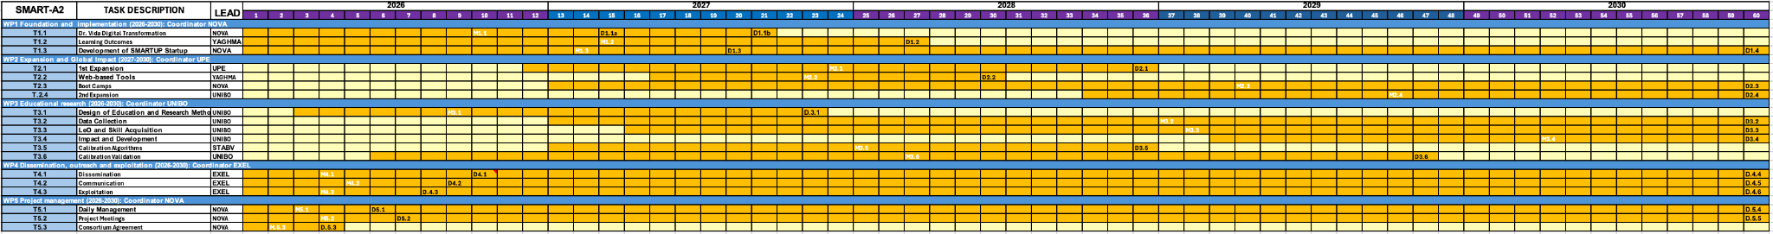

A downloadable copy of the Gantt chart can be found here: <https://smartupdreducation.wixsite.com/welcome/gantt-chart>

| **Total Protein Quantification in Urine.** Teachers and students will develop practical skills in protein quantification using colorimetric assays (e.g., Bradford) and spectrophotometry, focusing on sample prep, accuracy, and reproducibility. They will apply digital tools and Python for data analysis, visualization, and AI-based insights. The module links protein levels in urine to clinical conditions like myeloma and kidney disease, using synthetic urine and metadata. At the Master’s level, it expands to high-resolution mass spectrometry and metabolomics integration. High-throughput approaches support epidemiological studies and diagnostics. Core manuscripts8,9. Developers: UPE and YAGHMA. Testers: UNIBO, UNICAMP, TSNUK, UHU, NOVA, STABV, and UOA. Biostatistics: UOA. |
| --- |
| **Fluorescence.** Teachers and students will detect Hg, As, and bacteria in water using organic probes, linking analytical methods to toxicology, environmental health, and the *One Health approach*. The activity covers bacterial classification (Gram+/−), antibiotic resistance, and the impact of pollutants on ecosystems and public health. Students will apply microextraction techniques, digital imaging, and mobile tools (e.g., Dr. Vida Education), using Python and AI for data analysis. Skills include concentration calculations, LOD/LOQ, calibration, and statistical validation. **At the Master’s level,** the project scales to advanced techniques, including high-resolution and tandem mass spectrometry for precise identification and quantification, and explores the interaction Hg and As with biological systems through medical and environmental proteomics. **This comprehensive approach prepares teachers** for addressing food safety and environmental health challenges. Core manuscript[6],10: Developers: UHU, UNICAMP, UNIBO and YAGHMA. Testers: UPE, TSNUK, NOVA, STABV and UOA. Biostatistics: UOA |
| **PCR Diagnostics for Public Health: Lactose Intolerance, salmonella and legionella determination in water..** Teachers andStudents will gain **hands-on** expertise in molecular biology techniques such as **PCR setup, DNA/RNA extraction,** and gel electrophoresis for product verification. They will learn to operate and optimize **PCR thermocyclers,** analyze real-time PCR data, and apply automation through programming. Skills include quantitative analysis (Ct values, LOD/LOQ), statistical validation (sensitivity, specificity), and Python-based bioinformatics for PCR data processing, enhanced by AI integration for diagnostics. The project emphasizes interdisciplinary learning, covering public health implications of PCR in disease surveillance, epidemiology, and environmental health monitoring. Students will explore high-throughput PCR for large-scale studies, multiplex PCR for co-infection detection, and advanced applications like integrating proteomics and mass spectrometry (e.g., MALDI-TOF). **Scalable diagnostic** workflows for outbreak response and portable diagnostic kits will address critical issues like antimicrobial resistance and environmental health monitoring, preparing teachers and students for impactful roles in public health diagnostics. Core manuscripts11,12,13. Developers: NOVA, STABV, KYIV and YAGHMA. Testers: UNIBO, UPE, TSNUK, UHU, and UOA. Biostatistics: UOA |

**TABLE E.** Academic beneficiaries and expected future partners.

| The comprehensive list of 63 (49+4+10) universities includes: (i) 8 core HEIs (Academic beneficiaries); the 45 universities included in the Alliance of Alliances as presented in 1.1, and the following Brazilian universities; University of São Paulo, Federal University of Rio de Janeiro – UFRJ, Federal University of Minas Gerais – UFMG, São Paulo State University – UNESP, Federal University of Rio Grande do Sul – UFRGS, Federal University of Santa Catarina – UFSC, Federal University of Paraná – UFPR, University of Brasília. |
| --- |
|
|
|

**Table 3.1c: List of Deliverables**

| **No** | **Deliverable Name** | **Short Description** | **WP No** | **Short Name of Lead Participant** | **Type** | **Dissemination Level** | **Delivery Date**  **(In Months)** |
| --- | --- | --- | --- | --- | --- | --- | --- |
| D1.1a | Final prototype | Dr. Vida education digital | 1 | STABV | DEM | SEN | 15 |
| D1.1b | hands-on instructional guides | Instructions to implement Dr. Vida Education at the laboratory | 1 | NOVA | R | PU | 21 |
| D1.2 | Preliminary learning outcomes | Educational research targeting 500 students | 1 | UOA | R | PU | 27 |
| D1.3 | Presenting the educational startup SMARTUP | Creation of SMARTUP Startup to support the project | 1 | NOVA | R | SEN | 20 |
| D1.4 | SMARTUP consolidation | SMARTUP becomes a reference in educational technology and learning | 1 | NOVA | R | SEN | 60 |
| D2.1 | 1st expansion | 40 educators trained for the Dr. Vida Education device, hands-on works and statistics. 1500 students. + 16 HEIs | 2 | UPE | DEM | PU | 36 |
| D2.2 | Development of web-based tools | Tools related to the experimental practices | 2 | YAGHMA | DEC | PU | 30 |
| D2.3 | 48 innovation boots camps | Camps where educators can acquire hands on the Dr. Vida Education | 2 | NOVA | DEM | PU | 60 |
| D2.4 | 2nd expansion | 200 educators trained at NOVA-BIOSCOPE conferences for the Dr. Vida Education device, hands-on works and statistics. 10000 students. 49+4+10 HEIs | 2 | UNIBO | DEM | PU | 60 |
| D3.1 | Design of Educational Research Methodology | Research Protocol and Evaluation Toolkit | 3 | UNIBO | R | EUC | 23 |
| D3.2 | Data Collection During Educational Activities | Interim Data Report on Student and Teacher Perceptions | 3 | UNIBO | R | EUC | 60 |
| D3.3 | Analysis of Learning Outcomes and Skill Acquisition. | Analytical Report on Learning and Skills Impact | 3 | UNIBO | R | EUC | 60 |
| D3.4 | Long-Term Educational Impact and Resource Development | Longitudinal Impact and Institutional Feedback. Open Educational Resource (OER) Repository and Policy Briefs and Educational Recommendations | 3 | UNIBO | R | EUC | 60 |
| D3.5 | Quality control. Prototype integration | Development of calibration algorithms and internal QC materials.Final calibration guidelines and SOPs | 3 | STABV | R | EUC | 36 |
| D3.6 | Multicenter validation. Final calibration guidelines | Multicenter validation of calibration system. Final Calibration guidelines | 3 | UNIBO | R | PU | 47 |
| D4.1 | SMART website & social media | Launch of the website and social media channels | 4 | EXEL | DEC | PU | 10 |
| D4.2 | Data management plan | Report on the procedures for collecting, storing, sharing, and protecting project data to ensure compliance, transparency, and long-term accessibility | 4 | NOVA | DMP | SEN | 9 |
| D4.3 | Dissemination, documentation and exploitation plan | A detailed strategy for sharing project results, maintaining thorough documentation, and ensuring effective use and impact of project outcomes | 4 | EXEL | R | SEN | 8 |
| D4.4 | Consolidation of SMART website & social media | Success of the website and social media channels. Followers: 1500 on X, 800 on LinkedIn, 300 on Instagram | 4 | EXEL | R | SEN | 60 |
| D4.5 | Data management finalization | Final report on the procedures for collecting, storing, sharing, and protecting project data to ensure compliance, transparency, and long-term accessibility | 4 | EXEL | R | SEN | 60 |
| D4.6 | Dissemination, documentation and exploitation | Final report on project results and their dissemination | 4 | EXEL | R | SEN | 60 |
| D5.1 | Management handbook | Guidelines and best practices for managing the SMART project from start to finish | 5 | NOVA | R | SEN | 6 |
| D5.2 | Agenda and minutes of the kick off and annual meetings | Prepare, conduct and follow up the kick off and annual meetings | 5 | NOVA | R | SEN | 7 |
| D5.3 | Consortium Agreement | Consortium agreement signed | 5 | NOVA | R | SEN | 4 |
| D5.4 | Management assessment | Report on the effectiveness of guidelines and best practices for project management | 5 | NOVA | R | SEN | 60 |
| D5.5 | Agenda and minutes of all meetings | Carry out all meetings | 5 | NOVA | R | SEN | 60 |

**Table 3.1d: List of milestones**

| **Milestone**  **number** | **Milestone**  **Name** | **Related WP(s)** | **Due date**  **(in months)** | **Means of Verification** |
| --- | --- | --- | --- | --- |
| M1.1 | Dr. Vida Education  devices | 1 | M1.1: 10 | **M1.1:** 1/2 of the Dr. Vida Education devices must be Operational (100 units of 240). |
| M1.2 | Dr. Vida Education  Readiness, Practices Guidelines and | 1 | M1.2: 15 | **M1.2:** Half educational works must have been written and tested by the beneficiary responsible. |
| M1.3 | SMARTUP startup | 1 | M1.3: 14 | **M1.3:** All documents + web site ready to create the SMARTUP. |
| M2.1 | EU HEIs Engagement, | 2 | M2.1: 24 | **M2.1:** At least 8 new HEIs enrolled. Practices Guidelines available in the web page. |
| M2.2 | Web-based tools, | 2 | M2.2: 23 | **M2.2:** Final versions of Dr. Vida Education Readiness, |
| M2.3 | Boot Camps | 2 | M2.3: 40 | **M2.3:** At least 24 boot camps are done. |
| M2.4 | 2nd Expansion | 2 | M2.4: 46 | **M2.4:** At least 20 new HEIs. |
| M3.1 | Research plan | 3 | M3.1: 09 | **M3.1:** half of the research plan elaborated. |
| M3.2 | data collected. | 3 | M3.2: 37 | **M3.2:** half of total data collected. |
| M3.3 | statistics completed. | 3 | M3.3: 38 | **M3.3:** half of total statistics completed. |
| M3.4 | impact and development | 3 | M3.4: 52 | **M3.4:** Half impact and development assessed. |
| M3.5 | Calibration algorithms | 3 | M3.5: 25 | **M3.5:** Calibration algorithms and QC templates developed. |
| M3.6 | calibration module integrated | 3 | M3.6: 38 | **M3.6:** Prototype calibration module integrated into Dr. Vida Education. |
| M4.1 t | Dissemination | 4 | M4.1: 4 | **M4.1:** Half of the dissemination plan developed. |
| M4.2 | Communication |  | M4.2: 5 | **M4.2:** Half communication plan developed. |
| M4.3 | Exploitation |  | M4.3: 4 | **M4.3:** Half of the exploitation plan developed. |
| M5.1 | Day-to-day management, | 5 | M5.1: 3 | **M5.1:** *Project management framework established.* work plans, management protocols, financial guidelines, and gender equality integration strategy approved by all partners. |
| M5.2 | Project meetings | 5 | M5.2: 4 | **M5.2:** *Kick-off meeting held and documented*. Agendas, minutes, and action items archived in a centralized repository. |
| M5.3 | Consortium agreement | 5 | M5.3: 2 | **M5.3:** *Draft Consortium Agreement circulated*. All partners review and comment on IPR, confidentiality, and governance clauses. |

**Table 3.1e:Critical risks for implementation (level of likelihood/severity: Low (L),Medium(M),High(H)**#@RSK-MGT-RM@#

| **Description of risk** | **WP(s)** | **Proposed risk-mitigation measures** |
| --- | --- | --- |
| R.1 Number of students below expectations. L/H | 1 | The beneficiaries have access to many different subjects other than the chosen ones for this work for recruitment of students |
| R.2 Failure in creating SMARTUP. L/M | 1 | SMARTUP tasks will be taken by The Proteomass Scientific Society, partner of the NOVA-FCT-BIOSCOPE GROUP. |
| R.3 Partner departing consortium. L/M | 1 | The skills necessary for this project are redundant among beneficiaries |
| R.4 Delays in procurement and delivery of Dr. Vida Education. M/M | 1 | Establish procurement timelines early and include buffer periods. Identify multiple suppliers to ensure continuity. |
| R.5 Technical malfunction or underperformance of Dr. Vida Education in pilot HEIs. L/H | 1 | Conduct pre-deployment quality assurance testing; provide on-site/remote technical support; maintain spare units for rapid replacement |
| R.6 Scale adoption across Europe fails. L/L | 2 | The number of partners linked to beneficiaries is too large across Europe to fail. Web divulgation as an alternative. |
| R.7 Scale adoption outside Europe fails. L/L | 2 | The overseas partners (Brazil) linked to beneficiaries are large and important Brazilian universities to fail. Web divulgation as an alternative |
| R.8 Number of teachers below expectations. L/L | 2 | Recruitment already started a the SciEdu conference organized in 2025 by [NOVA](https://sciedu2025.com/). Too many universities involved (49+4+10) |
| R.9 Low engagement from partner HEIs in institutionalization phase. L/M | 2 | Maintain regular communication with HEI coordinators; provide incentives for engagement; showcase success stories |
| R10 Fail in making a robust device (calibration). L/L | 3 | TSNUK has a strong background in electronics. |
| R.11 Poor dissemination and outreach results. L/H | 4 | Clearly define the target audiences, key messages, dissemination goals, and outreach strategies at the beginning of the project. Establish Key Performance Indicators (KPIs) for dissemination efforts, such as website traffic, number of attendees at events, or citation counts. |
| R.12 Poor dissemination and outreach results. L/H | 4 | Clearly define the target audiences, key messages, dissemination goals, and outreach strategies at the beginning of the project. Establish Key Performance Indicators (KPIs) for dissemination efforts, such as website traffic, number of attendees at events, or citation counts. |
| R.13 Infringement of third-party Intellectual Property Rights. L/H | 4 | Conduct a thorough IPR Due Diligence at the project's outset, ensuring that all external IPR included in the project is identified, documented, and, if necessary, licensed appropriately. |
| R.14 Difficulty aligning curricula with accreditation requirements in target countries. M/M | 4 | Engage with accreditation bodies early; adapt training materials to local standards; involve local academic leaders in integration |
| R.15 Data privacy or GDPR compliance breach during student/teacher data collection. L/H | 4 | Implement GDPR-compliant protocols; train staff on privacy regulations; appoint a Data Protection Officer |
| R.16 Gender imbalanced teams. L/H | 5 | Establish clear and measurable gender diversity targets for the team, aligned with EIT’s emphasis on fostering inclusivity and gender equality in research. |

#§RSK-MGT-RM§#

**Table 3.1f: Summary of staff effort**

|  | **WP1** | **WP2** | **WP3** | **WP4** | **WP5** | **Total Person-Months per Participant** |
| --- | --- | --- | --- | --- | --- | --- |
| **1/NOVA** | 9 | 10 | 10 | 4 | 40 | 73 |
| **2/UNIBO** | 14.3 | 8 | 28.7 | 5 | 3 | 59 |
| **3/STABV** | 22 | 21 | 16 | 12 | 4.5 | 75.5 |
| **4/UOA** | 15 | 25 | 3 | 8 | 3 | 54 |
| **5/EXEL** | 6 | 6 | 0 | 30 | 4 | 46 |
| **6/UNICAMP** | 7 | 7 | 7 | 4 | 5 | 30 |
| **7/YAGHMA** | 7 | 17 | 4 | 3 | 9 | 40 |
| **8/UPE** | 7 | 7 | 7 | 4 | 5 | 30 |
| **9/TSNUK** | 19 | 19 | 7 | 16 | 3 | 64 |
| **10/UHU** | 7 | 8 | 3 | 4 | 5 | 27 |
| **Total Person Months** | **113.3** | **128** | **85.7** | **90** | **81.5** | **498.5** |

**Table 3.1g: ‘Subcontracting costs’ items**

| **1/ NOVA** | **Cost (€)** | **Description of tasks and justification** |
| --- | --- | --- |
| **Subcontracting** | 75,000 | Organisation of events related to WP1 (25,000€), WP2 (25,000€) and WP4 (25,000€) |

| **4/ UOA** | **Cost (€)** | **Description of tasks and justification** |
| --- | --- | --- |
| **Subcontracting** | 75,000 | Organisation of events related to WP1 (25,000€), WP2 (25,000€) and WP4 (25,000€) |

| **7/ YAGHMA** | **Cost (€)** | **Description of tasks and justification** |
| --- | --- | --- |
| **Subcontracting** | 75,000 | Organisation of events related to WP1 (25,000€), WP2 (25,000€) and WP4 (25,000€) |

| **10/ UHU** | **Cost (€)** | **Description of tasks and justification** |
| --- | --- | --- |
| **Subcontracting** | 50,000 | Organisation of events related to WP1 (25,000€) and WP2 (25,000€) |

**Table 3.1h:‘Purchase costs’ items (travel and subsistence, equipment and other goods, works and services)**

| **1/NOVA** | **Cost(€)** | **Justification** |
| --- | --- | --- |
| **Travel and subsistence** | 90,000 | Attending to project meetings (36,000€), dissemination (18,000€) and training events (36,000€) |
| **Other goods, works and services** | 135,000 | Consumables for training (44,000€) and research activities (75,000€); Organisation costs for training/networking events (16,000€) |
| **Total** | 225,000 |  |

| **2/UNIBO** | **Cost(€)** | **Justification** |
| --- | --- | --- |
| **Travel and subsistence** | 56,000 | Attending to project meetings (10,000€), dissemination (18,000€) and training events (28,000€) |
| **Other goods, works and services** | 70,000 | Consumables for training (36,000€) and research activities (4,000€); Organisation costs for training/networking events (30,000€) |
| **Total** | 126,000 |  |

| **3/STABV** | **Cost(€)** | **Justification** |
| --- | --- | --- |
| **Travel and subsistence** | 90,000 | Attending to project meetings (18,000€), dissemination (18,000€) and training events and secondments to partners (54,000€) |
| **Other goods, works and services** | 205,000 | Consumables for training activities (15,000€); Dissemination (open access), IP & market analysis (25,000€); Components and reagents for research activities (45,000€), services for electronics components and prototyping (120,000€). |
| **Total** | 295,000 |  |

| **4/UOA** | **Cost(€)** | **Justification** |
| --- | --- | --- |
| **Travel and subsistence** | 70,000 | Attending to project meetings (10,000€), dissemination (20,000€) and training events (40,000€) |
| **Other goods, works and services** | 95,000 | Consumables for training (24,000€) and research activities (5,000€); Organisation costs for training/networking events (66,000€) |
| **Total** | 165,000 |  |

| **6/UNICAMP** | **Cost(€)** | **Justification** |
| --- | --- | --- |
| **Travel and subsistence** | 102,000 | Attending to project meetings (42,000€), dissemination (12,000€)and training events (48,000€) |
| **Other goods, works and services** | 132,000 | Consumables for training (44,000€) and research activities (40,000€); Organisation costs for training/networking events (48,000€) |
| **Total** | 234,000 |  |

| **7/YAGHMA** | **Cost(€)** | **Justification** |
| --- | --- | --- |
| **Travel and subsistence** | 45,500 | Attending to project meetings (9,100€), dissemination (9,100€)and training events (27,300€) |
| **Other goods, works and services** | 54,000 | Server capacity for the digital platform (24,000€); APIs and database usage for toolkit developed, 500 euros per month for 60 months of the project (30,000€) |
| **Total** | 99,500 |  |

| **8/UPE** | **Cost(€)** | **Justification** |
| --- | --- | --- |
| **Travel and subsistence** | 102,000 | Attending to project meetings (42,000€), dissemination (12,000€)and training events (48,000€) |
| **Other goods, works and services** | 132,000 | Consumables for training (44,000€) and research activities (40,000€); Organisation costs for training/networking events (48,000€) |
| **Total** | 234,000 |  |

| **9/TSNUK** | **Cost(€)** | **Justification** |
| --- | --- | --- |
| **Travel and subsistence** | 100,000 | Attending to project meetings (30,000€), dissemination (30,000€)and training events (40,000€) |
| **Other goods, works and services** | 98,000 | Consumables for training (8,000€) and research activities (58,000€); Organisation costs for training/networking events (32,000€) |
| **Total** | 198,000 |  |

| **10/UHU** | **Cost(€)** | **Justification** |
| --- | --- | --- |
| **Travel and subsistence** | 90,000 | Attending to project meetings (42,000€), dissemination (18,000€)and training events (30,000€) |
| **Other goods, works and services** | 139,000 | Consumables for training (69,000€) and research activities (50,000€); Organisation costs for training/networking events (20,000€) |
| **Total** | 229,000 |  |

#§QUA-LIT-QL§# #§WRK-PLA-WP§#

**3.2. Capacity of participants and consortium as a whole** #@CON-SOR-CS@# #@PRJ-MGT-PM@#

**3.2.1 Consortium description and complementarity**

The SMART-A2 Project brings together a multidisciplinary and international consortium of **ten** leading institutions—including universities, research foundations, and innovative companies—each contributing specialized expertise to ensure the successful implementation of the project’s objectives. The consortium spans across Europe, Latin America, and Eastern Europe, providing a dynamic platform for knowledge exchange, innovation, and education aligned with the Knowledge Triangle: education, research, and innovation. Each partner contributes unique value: **NOVA University Lisbon (NOVA)** is a leader in proteomics and diagnostics, offering hands-on, interdisciplinary training in health technologies. It has extensive experience in Erasmus+ projects—**UDI-Africa**, **CABCIN**, **DIGITAQ**, and **e-DESK**—focused on teaching quality, digitalisation, and innovation. NOVA also contributes to blended learning and Master-level innovation (e.g. **Digital4Business**). Its **Bioscope Group** boosts international collaboration through over 6 conferences and 7 courses yearly, enhancing SMART-A2’s impact. **University of Bologna (UNIBO)** leads in omics and medicinal chemistry, with educational experience from **TOX-OER**, **OEMONOM**, and Master’s programs like **Forensic Chemical-Toxicological Analysis**. It is active in 90+ Erasmus+ actions, including **Educators for Impact**, **ECALFOR**, **EATHEN**, **EXPERES**, and **BordEUr**, reinforcing its strength in curriculum development and digital education. **University of Athens (UoA)** brings expertise in biomedicine, AI, and translational research. It supports SMART-A2 with biomedical capacity and links between omics and healthcare. UoA coordinates inclusive education projects like **Edu4ALL** and **KALCEA**, and contributes to **HumAct**, promoting humanitarian and climate-resilient education. **University of Huelva (UHU)** strengthens the consortium with expertise in environmental sciences, analytical chemistry, and sustainability. It coordinated **DIMPE** (digitalising multilingual programmes) and **STUPS** (inclusive student governance), enhancing science communication and participation. **Taras Shevchenko National University of Kyiv (TSNUK)** contributes in physics, environmental monitoring, and STEM education. It participates in **Global Teachers for a Sustainable Future** and **Digital University**, and supports adaptation of Dr. Vida Education content for Eastern Europe. **Exelixis Research Management & Communication (EXEL)** participates as a beneficiary responsible for dissemination, outreach and exploitation in ongoing H2020 and Horizon Europe projects such as **TO_AITION - 848146**, **MULTIR - 101136926, ELMUMY - 101097094, EXPAND-EV - 101182851, L2D2 - 101058079**. EXEL ensures efficient project coordination, dissemination, and stakeholder engagement. **YAGHMA B.V.** (Netherlands) specialises in ethical, legal, and societal governance of emerging technologies. It contributes to **TetRRIS**, **READJUST**, and **BioRadar**, with expertise in digital/green transitions, circular economy, and policy integration. **STAB VIDA (STABV)**, a Portuguese biotech SME at NOVA, contributes over 20 years of experience in molecular diagnostics, lab-on-chip, and precision tools. It has led or contributed to **LungCARD**, **DIRNANO**, and **NAD**, aligning with Horizon Europe’s innovation goals. **University of Campinas (UNICAMP)** is a top Brazilian university with strong educational innovation and Erasmus+ engagement. It was involved in **INCOBRA** (EU–Brazil cooperation), and leads national education programs like the **Unicamp and National History Olympiads**, promoting challenge-based learning. **University of Pernambuco (UPE)** supports inclusive, internationalised higher education. It took part in **SOLIDARIS**, **EQUITY-LA II**, and disease-focused FP7/H2020 projects. With 27 recent internationalisation initiatives under **COBRADI**, UPE offers solid operational capacity for education and health-focused EU collaborations.

1. Sánchez, J. M. (2022). Are basic laboratory skills adequately acquired by undergraduate science students? Analytical and Bioanalytical Chemistry, 414, 3551–3559.
2. Casado-Mansilla, D. (2023). Remote experiments for STEM education and engagement in rural schools: The case of Project R3. Technology in Society, 75, 102404.
3. Teichmann, E., Lewandowski, H. J., & Alemani, M. (2022). Investigating students’ views of experimental physics in German laboratory classes. arXiv preprint. https://arxiv.org/abs/2201.12145
4. Freeman, S., Eddy, S. L., McDonough, M., Smith, M. K., Okoroafor, N., Jordt, H., & Wenderoth, M. P. (2014). Active learning increases student performance in science, engineering, and mathematics. PNAS, 111(23), 8410–8415.
5. Prince, M. (2004). Does active learning work? A review of the research. Journal of Engineering Education, 93(3), 223–231.
6. Domingos, I. F., et al. (2024). Dithiothreitol-based protein equalisation in the context of multiple myeloma: Enhancing proteomic analysis and therapeutic insights. Talanta, 279, 126589. 9 Carvalho, L. B., et al. (2023). Pathway-guided monitoring of the disease course in bladder cancer with longitudinal urine proteomics. Communications Medicine, 3, 8. 10 Galhano, J., et al. (2024). Fluorescent polymers for environmental monitoring: Targeting pathogens and metal contaminants with naphthalimide derivatives. Journal of Hazardous Materials, 480, 136107. 11Mathur, S., et al. (2023). ChatGPT and artificial intelligence in laboratory medicine: Perspectives and potential. Journal of Applied Laboratory Medicine, 8(6), 1296–1305. 12 Gong, J. et al., 2024. One-tube detection of *Salmonella Typhimurium* using LAMP and CRISPR-Cas12b. *Microbiology Spectrum*, 12(10), e01271-24. 13Lee, E.S. and Han, J.S., 2022.Propidium monoazide-quantitative PCR to detect viable *Legionella* spp. in the supply process of tap water. *Water Supply*, 22(7), pp.6205–6212.